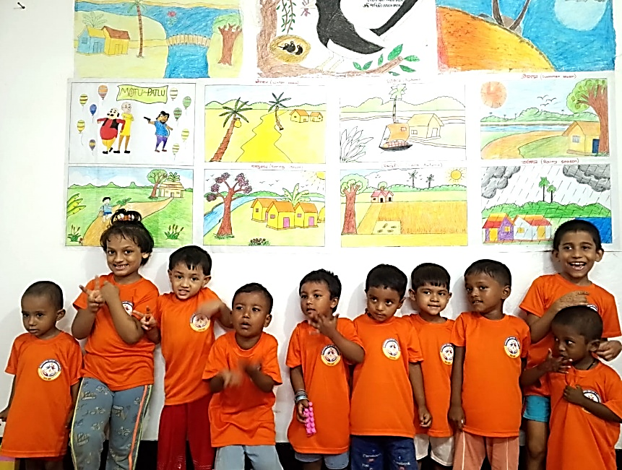  Grasshopper Day care & Kindergarten Project  Reporting Period: From 01-04-2025 To 31-03-2026 Name: Grasshopper Day Care and Kindergarten Region: Caritas Chattogram Prepared by: The project team, Chattogram Date of Submission: Apr 20,2026 | Annual Progress Report (April 2025-March 2026), Grasshopper Day Care and Kindergarten

Executive Summary
Despite global conflicts, instability, and ongoing economic challenges worldwide, Grasshopper Day Care and Kindergarten continued its dedicated efforts to ensure quality early childhood care and development for children under the Joyful and Grasshopper Daycare & Kindergarten Project. The center remained committed to promoting holistic Early Childhood Development (ECD) through quality care, nutrition support, and strong parental engagement. During the reporting period, the center recorded a cumulative enrolment of 85 children (47 boys and 38 girls). However, 49 children (27 boys and 22 girls) dropped out due mainly to family mobility, economic pressures, and changing caregiving arrangements. As a result, the active enrolment stood at 76 children, including 41 boys and 35 girls. To address dropout challenges, the project strengthened home visits, parental counseling, and community awareness initiatives to encourage regular attendance and sustained participation.
The center maintained an average attendance of 22.87 children, reflecting steady engagement among enrolled children. Development assessments demonstrated gradual improvement across key domains, including communication skills, social interaction, emotional regulation, and problem-solving abilities such as puzzle completion. Educators emphasized play-based learning, hands-on activities, and group interaction to support children’s physical, cognitive, and socio-emotional growth. Nutrition support remained a core component of the program. Children received balanced meals aligned with the project’s nutrition chart, including eggs, milk, fruits, vegetables, fish, and meat. Educators and day mothers ensured hygienic food preparation practices while actively discouraging junk food consumption, contributing to improved health and wellbeing among children.
Parental engagement was strengthened through six parent meetings and one ECD awareness seminar, reaching approximately 65% of parents. These sessions enhanced parents’ understanding of early childhood development and reinforced collaboration between families and the daycare center. Parent feedback remained highly positive, highlighting improvements in children’s confidence, learning progress, and overall safety. Community engagement activities further expanded awareness on child protection, nutrition, and gender equality. Events included social group meetings, adolescent and child group sessions, cooking demonstrations, and observance of key national and international days such as National Girl Child Day, World Children’s Day, Child Rights Day, National Safe Food Day, and International Women’s Day. These initiatives fostered a supportive and child-friendly community environment.
Capacity development of staff remained a priority throughout the year. Team members participated in orientations, reporting sessions, and specialized training on ECD material development, Day Care Center (DCC) management, and nutrition, benefiting both the Grasshopper and Ankur project staff. Overall, Grasshopper Day Care and Kindergarten demonstrated resilience and sustained impact by providing safe, nurturing, and development-focused services, contributing to improved early childhood outcomes for vulnerable children and strengthening family and community engagement in child development.
Key Achievements in April 2025 – March 2026:
- 85 children enrolled (47 boys, 38 girls), ensuring access to early childhood care for vulnerable families, with continued retention of 36 children despite high mobility challenges.
- Maintained average daily attendance of 22.87 children, reflecting strong engagement and trust among parents despite socio-economic constraints.
- Demonstrated improvement in child development, including communication (up to 45%), social play (~40–43%), and cognitive skills such as puzzle-solving and block stacking.
- Ensured 100% access to nutritious meals for enrolled children, promoting healthy growth through a balanced diet and improved hygiene practices.
- Supported 17 vulnerable parents with temporary childcare, enabling them to secure employment; 14 families continued enrolment, ensuring stability for children.
- Conducted 12 parents’ meetings with 361 participants (300 female, 61 male), strengthening parent–center collaboration and awareness on child development.
- Achieved approximately 75% parental participation, with increased adoption of positive parenting, hygiene, and early learning practices at home.
- Organized 1 ECD awareness seminar (22 parents), enhancing knowledge on nutrition, early stimulation, and responsive caregiving.
- Successfully implemented 31 community engagement activities, including social group meetings, adolescent sessions, child group meetings, cooking demonstrations, and day observances.
- Engaged 248 women and 175 children through social and child group meetings, promoting awareness on child protection, hygiene, and community wellbeing.
- Empowered adolescent girls through 2 dedicated group sessions, improving knowledge on health, safety, and confidence-building.
- Strengthened community awareness through 4 national/international day observances with 196 participants, promoting child rights, gender equality, and safe food practices.
- Enhanced staff capacity through multiple trainings (nutrition, ECD materials, DCC management, reporting, and orientation), improving service quality and program delivery.
Details Report of April 2025 – March 2026:
Enrolment and Dropout during the reporting period
Gender identity | Previous | During the reporting period |  | Cumulative
Gender identity | Previous | Enrolment | Drop out | Cumulative
1 | 2 | 3 | 4 | 5(3-4)
Boys | 0 | 47 | 27 | 20
Girls | 0 | 38 | 22 | 16
Total | 0 | 85 | 49 | 36
The above table presents the enrolment and dropout status of children during the reporting period, disaggregated by gender. Total 85 children were enrolled and 49 children dropped out. The program currently retains 36 children, with a slightly higher number of boys (20) than girls (16)
Reasons for Dropout (April 2025 – March 2026)
During the reporting period, child dropout remained a recurring challenge for the daycare and kindergarten services. The primary contributing factors included:
- Job changes and relocation, as many parents moved to new workplaces or residential areas where access to nearby daycare or kindergarten facilities was limited.
- Irregular wages and employment insecurity among parents working in low-income sectors are affecting their ability to maintain consistent childcare arrangements.
- Parental separation and family conflict, which created instability within households and resulted in children being withdrawn from the center.
- Financial hardship, compelling parents to send children back to their villages or place them under the care of relatives, particularly grandparents.

To support vulnerable families during periods of unemployment, the centre provided temporary childcare assistance, allowing parents to keep their children safely enrolled while actively seeking employment. During the reporting period, 17 parents (parents of 7 girls and 10 boys) received this support. All beneficiaries successfully secured employment, and 14 families continued enrolling their children at the centre, recognizing the importance of a stable and secure learning environment.

Actions Taken to Minimize Dropout
Recognizing that periodic dropout is a common challenge in urban daycare settings, the project team implemented several proactive measures throughout April 2025–March 2026 to reduce child withdrawal and promote sustained participation:
- Regular parental counseling through home visits emphasized the long-term benefits of consistent attendance and the importance of early childhood care for children’s cognitive, emotional, and social development.
- Home visits and community outreach activities were conducted to re-engage absent families and encourage new enrolments.
- Field visits to newly arrived families in surrounding communities helped raise awareness about available daycare and kindergarten services.
- Parent meetings addressed family conflict and child wellbeing, highlighting how unresolved disputes can negatively affect children’s emotional and social development and encouraging parents to prioritize children’s stability.
- Management Committee members and social group representatives supported outreach efforts by disseminating Day Care Centre (DCC) information within the community and helping reconnect families with services.

Despite these efforts, occasional service disruptions occurred due to limited field staff capacity, which constrained regular follow-up activities. To strengthen monitoring and ensure continuous family engagement, the project recommended assigning a dedicated staff member for routine field visits. A modest budget increase has also been proposed to support additional operational responsibilities and sustain effective follow-up mechanisms.

Attendance:
Gender | Previous | Attendance Rate during the reporting period | Comments (if any)
Boys | 0 | 16.47
Girls | 0 | 12.78
Total | 0 | 29.25

During the reporting period, the overall attendance at the Grasshopper Day Care and Kindergarten demonstrated as 29.25 while it is 16.47 for boys and 12.78 for girls. The combined rate of attendance stand as 29.25 reflecting parents’ trust and children’s enthusiasm for regular participation in the center’s daily learning and care activities.

This attendance trend highlights the center’s success in maintaining engagement among enrolled children despite various socio-economic challenges faced by families, such as parental work migration and occasional illness. The balanced participation between boys and girls also indicates a gender-inclusive environment where equal opportunities for early learning and play are ensured. Efforts by educators and day mothers—such as maintaining close communication with parents, ensuring a safe and nurturing atmosphere, and incorporating playful learning activities—have positively influenced regular attendance. Continued parental motivation, community outreach, and follow-up with irregular attendees are planned to improve consistent participation in the upcoming months further.

Children Development Assessment:

Development Area | No. Assessed (Boys / Girls) | Indicator | Prev (%) | Curr. (%) | Ave (%) | Comm.
Puzzle Completion | Boys: 20 | % completed independently | 0 | 5(25.0%)
Puzzle Completion | Girls: 16 | % completed independently | 0 | 4(25.0%)
Stacking Blocks | Boys: 20 | % completed independently | 0 | 8(40.0%)
Stacking Blocks | Girls: 16 | % completed independently | 0 | 9(56.25%)
Expressing Needs/Experiences | Boys: 20 | % expressed independently | 0 | 9(45.0%)
Expressing Needs/Experiences | Girls: 16 | % expressed independently | 0 | 6(38.0%)
Social Play & Group Interest | Boys: 20 | % participated independently | 0 | 8(40.0%)
Social Play & Group Interest | Girls: 16 | % participated independently | 0 | 7(43.75%)
Emotional Regulation | Boys: 20 | % controlled impulses | 0 | 4(20.0%)
Emotional Regulation | Girls: 16 | % controlled impulses | 0 | 3(18.75%)
Physical Activities (Running, Jumping, etc.) | Boys: 20 | % performed independently | 0 | 13(65.0%)
Physical Activities (Running, Jumping, etc.) | Girls :16 | % performed independently | 0 | 3(18.75%)
During the reporting period, regular developmental assessments were conducted to evaluate children’s progress across key Early Childhood Development (ECD) domains — cognitive, emotional, physical, and social. The assessment results indicate gradual and positive improvement in children’s abilities compared to the baseline situation. In the area of cognitive development, progress was evident through activities such as puzzle completion and stacking blocks. Approximately 25% of boys out of 20 and 25% of girls out of 16 completed puzzles independently, while 40% of boys out of 20 and 56% of girls out of 16 were able to stack blocks without assistance. These achievements reflect growing problem-solving skills, concentration, and hand-eye coordination.
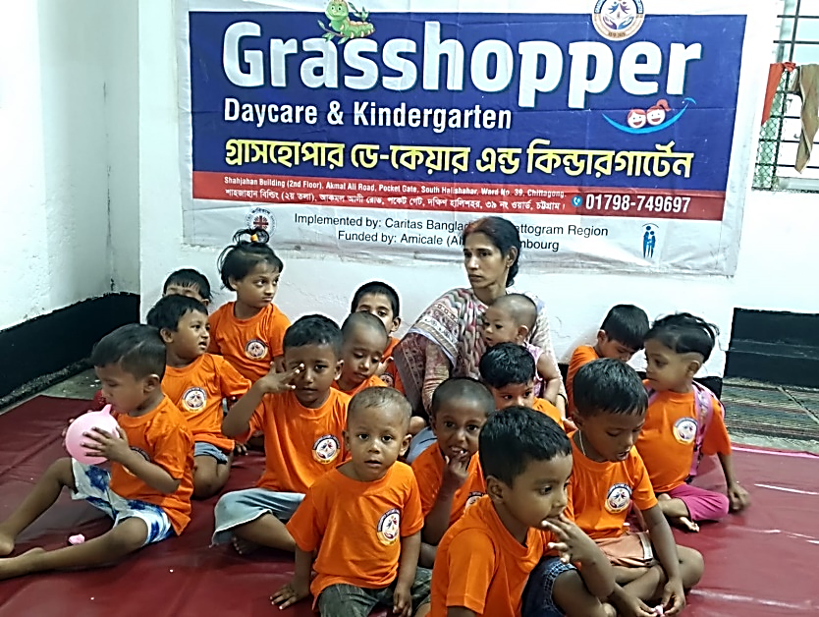
In terms of language and communication, around 45% of boys out of 20 and 38% of girls out of 16 were able to express their needs and experiences independently — a notable indicator of improving self-confidence and verbal development. For social and emotional development, 40% of boys out of 20 and 43.75% of girls out of 16 actively participated in group play and social activities, showing an increased sense of cooperation and peer interaction. However, emotional regulation remains an area requiring continued attention, with only 20% of boys out of 20 and 18.75% of girls out of 16 demonstrating self-control and impulse management. Educators are focusing on storytelling, guided play, and empathy-building exercises to strengthen this skill.
Regarding physical development, boys showed relatively higher performance, with 65% participating independently in running and jumping activities, while 18.75% of girls demonstrated similar physical activity levels. The difference reflects varying levels of physical confidence and engagement, which educators are addressing through inclusive play and movement-based exercises. Overall, the assessment results demonstrate steady developmental progress among children, underscoring the effectiveness of the centre’s structured play-based learning environment. Continued emphasis on individualized attention, balanced nutrition, and active parental engagement is expected to further enhance children’s overall growth in the next assessment cycle.
Nutrition support for DCC children:
One of the main objectives of Grasshopper Day Care and Kindergarten is to provide nutritious food to the children. It is ensured that all admitted children receive balanced, nutritious food as per the approved nutritional list. The center maintains a well-organized daily meal routine, which includes eggs, milk, Nutrimix (homemade Horlicks), seasonal fruits, sweet desserts, semolina, biscuits, rice, roti, meat, fish, mixed seasonal vegetables, and pulses. This varied diet aims to meet the nutritional needs of the children and help in their physical growth, cognitive development, and overall well-being.
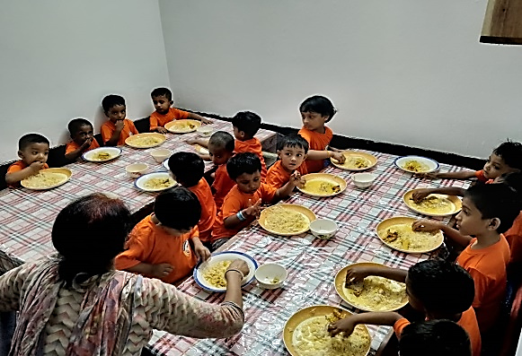
All Educators and Day-mothers at the daycare center are trained in nutritional food preparation, cooking, preservation, and hygiene. So that they can apply these skills in the daycare center and at their home, this ensures continuity of healthy eating habits. The center is strict against junk food, which helps instill healthy eating habits in children from an early age. Now all the educators know how to measure nutrition level of each child. Mealtimes at the daycare center are designed as learning and social development opportunities. Children sit together during meals to promote a sense of equality and belonging. Older children help their classmates wash their hands and prepare food, which further reinforces the values ​​of cooperation, hygiene, and discipline.
Parents are also encouraged to follow similar food habits at home, particularly emphasizing hand washing before eating and offering nutritious, home-cooked meals. This joint effort between parents and daycare staff strengthens children’s understanding of good nutrition and hygiene practices, contributing to their long-term health and development. Overall, the nutrition program continues to play a vital role in enhancing children’s health, concentration, and participation in daily learning activities, reflecting the project’s commitment to holistic child development.

Parents Engagement: (Meetings//Seminars/Demonstration):

SL | Events Held | Target | Achievements | Remarks
1 | Parents Meeting | 12 | 12
2 | ECD Awareness Seminar | 1 | 1
3 | % of Parents Attended | 90% | 75%

Parents’ Meetings and Discussion Sessions (April 2025 – March 2026)
During the reporting period (April 2025 – March 2026), Grasshopper Day Care Center continued to organize monthly parents’ meetings as a key strategy to strengthen collaboration between families, educators, and project staff. These meetings emphasized the critical role of parental involvement in children’s overall growth and development while creating an open and supportive platform for dialogue and shared learning.

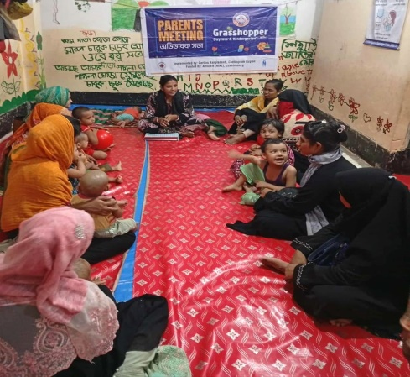
A total of 12 parents’ meetings were conducted during the year, with 361 participants (300 female and 61 male) attending. The sessions provided opportunities for teachers to share updates on each child’s developmental progress, including learning achievements, behavioral observations, and social interactions. Parents were encouraged to discuss their own experiences, challenges, and expectations, fostering a two-way exchange that supported continuity of care both at home and at the daycare center. Key discussion topics included child nutrition, hygiene practices, mental well-being, positive parenting, and strategies for supporting early learning at home. Meetings often incorporated demonstrations and participatory discussions, making sessions practical and relatable for parents. Through this regular engagement, parents reported becoming more aware of the importance of early stimulation, positive reinforcement, and consistent attendance.

Out of the parents of 36 enrolled children, approximately 75% regularly attended these sessions, indicating steady engagement while highlighting opportunities for further improvement in participation. Many parents expressed that the meetings helped them better understand their children’s developmental needs and strengthened communication with teachers. Several guardians noted that they now apply learned practices—such as interactive play, improved hygiene habits, and structured routines—within their households. Overall, the initiative strengthened the home–centre partnership, contributing to a nurturing and coordinated environment that supports children’s holistic development.

ECD Awareness Seminar (April 2025 – March 2026)
As part of ongoing efforts to enhance parental understanding of Early Childhood Development (ECD), Grasshopper Day Care and Kindergarten organized an ECD Awareness Seminar during the reporting period, conducted alongside a regular parents’ meeting. A total of 22 parents participated in the session.

The seminar focused on increasing awareness of critical stages of child development from the prenatal period to six years of age. Key discussion areas included maternal and child nutrition, emotional bonding, early stimulation, play-based learning, hygiene practices, and responsive caregiving. Educators shared practical demonstrations and simple home-based activities that parents could easily apply to support their children’s physical, cognitive, and emotional growth. Parents actively engaged in discussions, sharing personal experiences and raising questions related to daily caregiving challenges. Many participants expressed that the session helped them recognize their essential role in nurturing children’s development through consistent interaction, affection, and supportive learning environments at home—not only through formal education. Overall, the ECD awareness seminar strengthened parental knowledge, confidence, and commitment toward early childhood care and education, reinforcing the center’s vision of a holistic, community-based approach to child development.
Parental Feedback and Participation (April 2025 – March 2026)
Parental feedback remained an important element of the center’s continuous improvement process during the April 2025 – March 2026 reporting period. Approximately 75% of parents regularly participated in parent meetings, where they actively shared opinions, suggestions, and experiences regarding the center’s services and their children’s development. Parents consistently expressed satisfaction with the quality of care, safety measures, nutrition support, and early learning opportunities provided at Grasshopper Day Care & Kindergarten. Many guardians reported noticeable improvements in their children’s learning abilities, social interaction, discipline, and overall confidence since enrolling in the center.
Mukta Begum, a guardian of Grasshopper Kindergarten, shared her experience: “I have two daughters, Jamiya and Jannat. I have kept them in this day-care center for a year. Before enrolling them here, I faced many difficulties managing their care. Now I feel completely relaxed. They can play, eat nutritious food, and most importantly, they are learning to read. Every day they learn new rhymes, poems, and letters. I am very happy to keep my daughters in this day-care center.”
Similar feedback was echoed by many other parents throughout the reporting period. During parent meetings, guardians frequently expressed appreciation for the safe and nurturing environment of the center and acknowledged its positive role in supporting both children’s development and parents’ ability to work with peace of mind. Several parents also encouraged neighboring families to enroll their children, reflecting growing trust and community confidence in the daycare services. Overall, parental feedback demonstrates strong satisfaction, active engagement, and increasing community endorsement of the center as a reliable and supportive space for early childhood care and education.
Community Engagement and Outreach (April 2025 – March 2026)
During the reporting period, the Grasshopper Day Care and Kindergarten actively strengthened its engagement with the local community to enhance awareness of early childhood development (ECD), nutrition, hygiene, and child protection. A range of community-based activities—including household visits, social group meetings, demonstrations, and awareness events—created opportunities for parents, children, and community members to participate in meaningful learning and dialogue.

These initiatives aimed to build a supportive environment around children, promote positive caregiving practices, and encourage collective community responsibility for children’s wellbeing and development. Regular community visits enabled project staff to identify challenges faced by families, provide practical guidance, and motivate parents to enroll their children and ensure consistent attendance at the daycare center. Community members expressed positive opinions regarding these engagement efforts. Parents and local residents shared that awareness sessions helped them better understand child nutrition, hygiene practices, and the importance of early learning and emotional care. Several participants noted that they had adopted improved caregiving practices at home, such as maintaining hygiene routines, preparing nutritious meals, and spending more interactive time with their children. Mothers’ groups and local community representatives also appreciated the center’s inclusive approach, highlighting that the activities strengthened community cooperation and created a shared sense of responsibility toward children’s safety and development.

Participants further mentioned that regular interaction with project staff increased their confidence in seeking advice related to child care and family challenges. Many community members encouraged the continuation and expansion of such initiatives so that more families in surrounding areas could benefit from similar services.
Overall, these engagement efforts significantly enhanced community awareness of child wellbeing and strengthened collaboration among families, educators, and local social networks, ensuring that children experience a nurturing, protective, and inclusive environment both at home and within the daycare center.

Engagement of Community:
SL | Events | Target | Achievements | Remarks
1 | Social Group Meeting | 12 | 12
2 | Adolescents Group meeting | 2 | 2
3 | Child Group meeting | 12 | 12
4 | Cooking method Demonstration | 1 | 1
5 | Day Observation | 4 | 4

Community engagement remained a vital component of the Grasshopper Daycare & Kindergarten Project during the reporting period, aiming to strengthen awareness, participation, and collective responsibility toward child development and family well-being. A total of 31 community-based events were successfully conducted, meeting the planned targets. These included 12 social group meetings, 2 adolescent group meeting, 12 child group meetings, 1 cooking method demonstration, and 4 day observation event. The social group meetings involved local women and caregivers who discussed key social issues such as child protection, nutrition, hygiene, and food security. These sessions helped empower participants with knowledge and fostered peer learning and cooperation among community members.

The adolescent group meeting provided a safe and supportive platform for teenage girls to discuss topics related to personal health, safety, and empowerment. It encouraged them to become informed and responsible members of their community. The child group meetings focused on promoting teamwork, moral values, and creative expression through play and interactive learning, contributing to children’s confidence and social development. A cooking method demonstration was conducted to enhance community knowledge about nutritious food preparation, emphasizing the importance of maintaining food quality and hygiene during cooking. Lastly, Day Observation, such as National Girl Child Day, was celebrated with active participation from parents, children, and community members. The event highlighted the significance of gender equality, child rights, and a safe environment for all children. Overall, these community engagement activities played a crucial role in building awareness, promoting inclusiveness, and strengthening community ownership of early childhood care and development initiatives around the daycare centre.

Types of Events Organised:
Group Meeting (Social, Adolescents and Child):
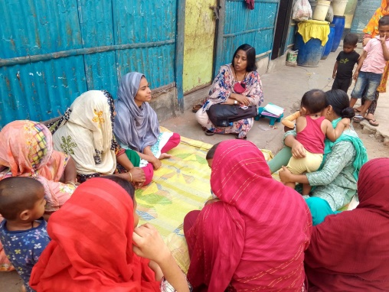
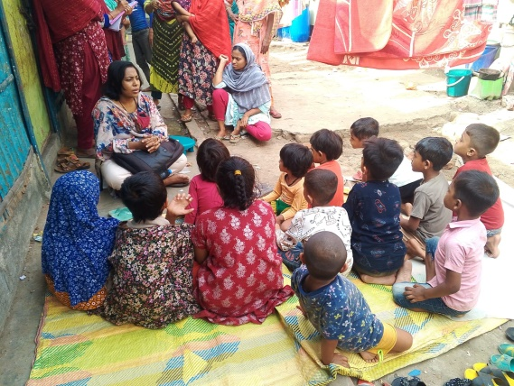
Social and Children Group Meeting: A total of 24 (12 social and 12 children group) social & children group meetings were conducted with active participation of 248 women and 175 children (boys- 78 and girls 97). The sessions focused on key social topics, including child protection, food security, hygiene, sanitation, and community wellbeing. These gatherings provided opportunities for participants to exchange ideas, learn practical solutions, and support one another in overcoming household and social challenges.
Through these interactive discussions, women shared personal experiences and identified common issues affecting their families and community. The initiative has significantly contributed to enhancing awareness, fostering social cohesion, and empowering women to play proactive roles in promoting healthy and child-friendly communities. The meetings also strengthened communication between the daycare centre and local families, helping to align community practices with the goals of early childhood development. This participatory approach has proven instrumental in sustaining positive behavioral changes within the community.
Adolescent Group:
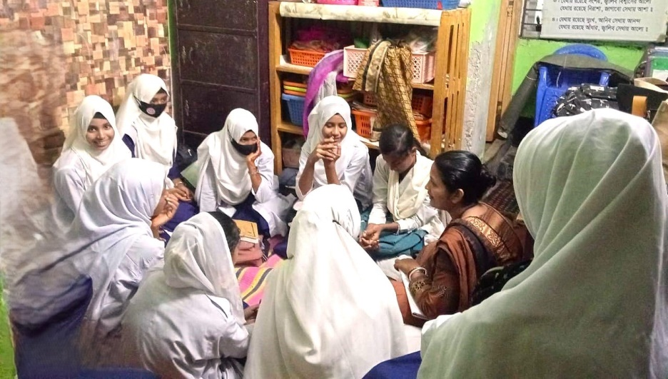
A dedicated group of teenage girls from the local community has been formed to create a safe and supportive space for learning, sharing, and empowerment. The primary objective of this group is to raise awareness about critical issues that directly impact adolescents’ health, safety, education, and overall well-being. During the reporting period, 2 adolescent group meeting was successfully conducted, focusing on topics such as personal hygiene, nutrition, mental health, early marriage prevention, and self-confidence building. The sessions encouraged open dialogue, allowing the girls to express their thoughts and concerns freely.
This initiative has helped strengthen the girls’ understanding of their rights and responsibilities and
motivated them to take positive steps toward personal growth and community contribution. It also serves as an early intervention platform to guide adolescents through a crucial stage of development, ensuring they grow into informed, confident, and responsible young women.
Cooking Method Demonstration: 01 cooking method demonstration session was organized with the active participation of 24 women members from the social groups. The session provided practical, hands-on guidance on identifying foods with high nutritional value and preparing them while retaining their quality, taste, and nutrient content. Participants learned about the importance of balanced diets for children, proper food hygiene, and cooking techniques that preserve vitamins and minerals. This activity not only enhanced participants’ nutritional awareness but also encouraged them to apply healthy cooking practices both at home and within their communities to ensure better family health and well-being.

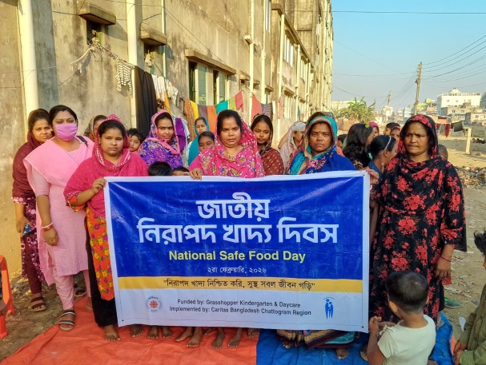
Day Observation: Grasshopper Kindergarten organizes awareness programs at the community level through various day celebrations on safe food, child protection, women empowerment, etc. During this reporting period, this 4-day event was celebrated and 196 people participated. National Girl Child Day Celebration: The National Girl Child Day, World Child Day, National Safe Food Day, International Women’s Day was celebrated at Grasshopper Kindergarten with great enthusiasm. A total of 196 participants attended the event, including 116 women, 21 men, and 59 children, representing parents, community members, and daycare children. The celebration of these days has served as an inspiring platform to spread awareness on child rights, girl child rights, safety and empowerment of women, and safe food.

Lesson plan preparation session:
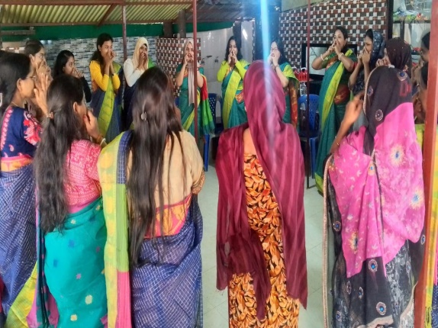
Lesson plan preparation sessions have been organized for the staff to ensure the care, growth and development of children of Grasshopper Kindergarten. These sessions included topics such as creating an effective routine for managing children’s activities, safety and child protection, child rights, appropriate and inappropriate behavior with children, training in making different types of toys that help children development and collect recycle materialss. The staffs are now effectively using their own materials and toys to help children learn through play. They are also teaching children through their own stories and rhymes on various topics such as nature and environment, fairy tales and vegetables. These activities have contributed significantly to enhancing the skills and teaching abilities of the staff.

Community Feedback and Engagement (April 2025 – March 2026)
During the reporting period of April 2025 to March 2026, community members expressed strong appreciation and satisfaction regarding the activities and positive impact of Grasshopper Day Care & Kindergarten. Parents, local women, and adolescent groups recognized the center’s significant contribution to promoting Early Childhood Development (ECD), improving child nutrition, and enhancing parental awareness on hygiene, positive discipline, and effective parenting practices.

Community participants reported that regular social group meetings, awareness sessions, and cooking demonstrations strengthened their knowledge of child care, nutritious food preparation, maternal health, and child protection practices. Many parents observed visible improvements in their children’s social interaction, communication abilities, and overall confidence after attending the center. Local leaders and mothers’ groups particularly appreciated the center’s inclusive and community-based approach, noting that it has fostered stronger community bonding and encouraged shared responsibility for children’s wellbeing. Participants encouraged Caritas Bangladesh to continue and expand similar initiatives to reach more vulnerable families in neighboring communities. ………., a regular member of the -------------- Social Group, shared her experience:
“I attend the meeting here every month. I have learned many important things, especially about child care, preparing nutritious food, and caring for pregnant mothers.”

Overall, community feedback during the reporting period reflects a high level of trust, cooperation, and growing community ownership, demonstrating the center’s evolving role as a sustainable, community-based model for nurturing early childhood care and education.

Staff Development of the team:
SL | Events | Target | Achievements | Remarks
1 | Training on nutrition | 18 | 18 | Grasshopper& Ankur team
2 | Project Orientation Training (person) | 5 | 5
3 | Session on preparing the report (person) | 5 | 5
4 | Training on developing ECD material & DCC management | 3 | 3
During the reporting period, staff development remained a key focus to ensure high-quality delivery of early childhood care and education services.
The staff participated in several capacity-building activities, including:
- Training on nutrition and cleanliness for Educators, Day mothers and Caregivers to increase the knowledge of educators, day-mothers, and caregivers on nutritious food, cleanliness, and serving nutritious food to children.
- Project Orientation Training to providing a comprehensive understanding of project objectives, policies, and implementation strategies.
- Reporting Skills Sessions for enhancing their ability to maintain accurate records, compile progress reports, and analyze data effectively.
- Training on Developing ECD Materials and DCC Management for focusing on curriculum development, age-appropriate learning materials, child-centered pedagogy, and efficient management of daycare operations.
These trainings strengthened staff knowledge and skills in child development monitoring, classroom management, and community engagement, enabling them to deliver better care, learning experiences, and support to children and parents. Continuous professional development has contributed to improved staff confidence, motivation, and capacity to implement project activities effectively.
Overall Centre Performance, Observation & Actions to take:
The overall performance of the Grasshopper Day Care & Kindergarten during the reporting period has been reaching satisfactory and impactful level, with visible progress in children’s physical, cognitive, social, and emotional development. The daycare continues to serve as a safe, inclusive, and stimulating environment where children receive care, education, and nutrition in an integrated manner.
Performance Highlights:
- Child Development: Regular assessments show noticeable improvement in fine and gross motor skills, communication abilities, and social interactions among children. Activities such as puzzle completion, stacking blocks, and group play have enhanced both problem-solving and teamwork skills.
- Nutrition Support: Implementation of the nutrition chart has ensured a balanced diet for all the children. The prohibition of junk food and emphasis on hygiene practices, such as hand washing before meals, are promoting healthy habits among both children and parents.
- Parental Involvement: Monthly parent meetings and ECD seminars have increased parents’ understanding of early childhood development. Although attendance was 65%, but those present actively shared constructive feedback and expressed satisfaction with the care and progress of their children.
- Community Engagement: All targeted community activities were achieved, contributing to awareness and participation in ECD, nutrition, and child rights.
Observations:
- Some parents face time constraints, leading to reduced participation in meetings and activities.
- A few children require additional attention in speech and emotional development, which educators are addressing through individualized follow-up.
- Community interest in ECD activities has grown, indicating strong potential for expanding outreach initiatives.
Actions to take in future
- Strengthen follow-up with parents to increase participation in future meetings and ECD awareness sessions.
- Introduce regular home visits or parent mentoring sessions to reinforce ECD practices at home.
- Continue teacher capacity-building training on child development monitoring and inclusive learning methods.
- Explore opportunities to engage local volunteers and youth in supporting daycare operations and community awareness events.
- Maintain strong linkages with local health and education services to ensure comprehensive child support.
Overall, the daycare is working relentlessly to perform well in fulfilling its objectives of nurturing children’s holistic growth, promoting family engagement, and fostering community collaboration for sustainable early childhood development
Conclusion:
During the reporting period (April 2025 – March 2026), Grasshopper Day Care and Kindergarten reaffirmed its strong commitment to ensuring quality early childhood care and development for children from underprivileged families in the Chattogram region. Despite ongoing challenges—including irregular attendance, child dropouts, parental job instability, and frequent relocation of families—the center consistently maintained its focus on providing joyful learning opportunities, nutritious meals, and a safe, nurturing environment for every enrolled child. Operating within a densely populated industrial setting where child-friendly spaces are limited, the center continued to serve as a reliable support system for working parents and a protective learning environment for children. Through dedicated efforts in education, nutrition support, parental engagement, and community outreach, the project tries to improve children’s development, parental awareness, and community participation in early childhood care. Looking ahead, the center aims to further strengthen its services by creating an even more child-friendly environment, reducing dropout rates through enhanced follow-up and family engagement, expanding enrolment through deeper community outreach, increasing parental awareness, and continuing capacity development for staff members. The experience of the reporting period demonstrates that accessible daycare and kindergarten services play a vital role in supporting working families and safeguarding children’s early years. Expansion of similar community-based daycare models would create greater opportunities for working parents while ensuring that more children grow up in a safe, caring, and developmentally supportive environment.

