Caritas Bangladesh
Joyful Day care & Kindergarten Project
Annual Progress Report
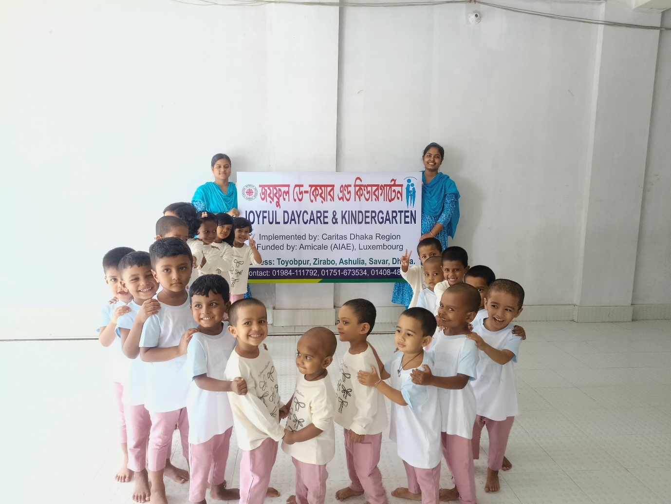

Reporting Period: From: 01-04-2025 to: 30-03-2026
Centre Name: Joyful Day Care and Kindergarten
Region: Caritas Dhaka Region
Name of the Donor organisation: AIAE-Luxembourg
Date of Submission: 31-03-2026

1General Information:
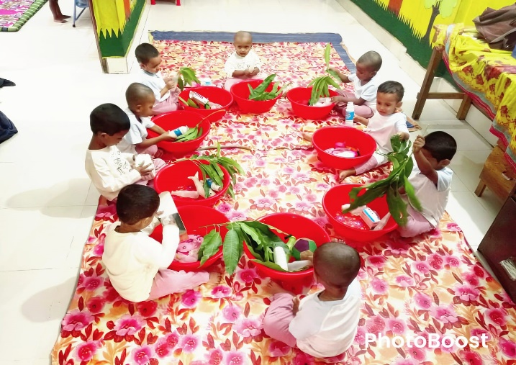
Introduction:
Caritas Dhaka Region is working with children, parents,
and the community through the “Joyful Day-Care and Kindergarten” project to ensure the safety and development of children of low-income working mothers living in the industrial areas of Ashulia, under Savar Upazila of Dhaka District. The project focuses on the care, growth, and development of children whose parents work in various garment factories. They belong to the marginalized groups. Through playful learning activities, children are being prepared for school. They are supported to develop socially, physically, intellectually, linguistically, and emotionally through different child-friendly games and activities.
1.1. Enrolment:
Gender | Previous (April 2025-Sep 2025) | Current (October 25-March 2026) | Cumulative (2+3) | Comments (if any)
1 | 2 | 3 | 4
Boys | 21 | 05 | 26
Girls | 11 | 08 | 19
Total | 32 | 13 | 45
1.2. Dropout:
Gender | Previous (April 2025-Sep 2025) | Current (October 25-March 2026) | Cumulative (3+4) |  | Comments (if any)
1 | 3 | 4 |  | 4
Boys | 08 | 08 |  | 16 | Note -below
Girls | 04 | 05 |  | 9
Total | 12 | 13 |  | 25

Note:
During the reporting period April 2025 to March 2026, 45 children were enrolled and 25 children dropped out. As of March 2026, the number of children stands at 20.

Reasons of drop out:
- Several small factories in the working area have been closed, resulting in the children's guardians losing their jobs. Due to financial difficulties, the guardians have sent the children from the daycare to their village homes.
- Due to financial difficulties, the guardians became indebted and left the area. Additionally, the child’s parents changed jobs and moved to another area. As the daycare is far away, they were unable to enroll the child.
- Due to family conflicts and disputes between the child’s parents, they have separated and the child has been taken away from the daycare center.
Actions Taken to Minimize Dropout:
- The child survey work is ongoing. Parents have been provided with information about job opportunities in various garments and factories and are being connected to potential employers. If they are employed, they can send their children to the center.
- New families who have come into the area have been informed about the daycare and kindergarten services.
- Parents have also received counseling on family matters. They have been made aware that family separation hinders a child’s development. This needs extra care but due to staff shortage, it remains unattended (community mobilization-gender based violence).

3. Attendance:

Gender | Previous (April 2025-Sep 2025) | Current (October 25-March 2026) | Cumulative (2+3) | Comments (if any)
1 | 2 | 3 | 4
Boys | 13.0 | 9.67 | 11.33
Girls | 7.3 | 10.33 | 8.81
Total | 10.15 | 10.00 | 10.07 | Attendance on average is 10.07

During the reporting period, the register-maintained reveals that attendance figures in the class varied from the highest 13 to the lowest 9.7 in case of boys while that varied from the highest 10.33 to the lowest 7.3 in case of girls. The average figure accounted for 10.07.

4. Children Development Assessment:

Development Area | No. Assessed (Boys / Girls) April.25- March.26 | Indicator | Previous (%) | Current (%)
Puzzle Completion | Boys: 17 | % completed independently | 43% | 65%
Puzzle Completion | Girls: 11 | % completed independently | 45% | 57%
Stacking Blocks | Boys: 18 | % completed independently | 48% | 69%
Stacking Blocks | Girls: 14 | % completed independently | 55% | 73%
Expressing Needs/Experiences | Boys: 16 | % expressed independently | 38% | 62%
Expressing Needs/Experiences | Girls: 12 | % expressed independently | 45% | 63%
Social Play & Group Interest | Boys: 17 | % participated independently | 43% | 65%
Social Play & Group Interest | Girls: 14 | % participated independently | 55% | 73%
Emotional Regulation | Boys: 10 | % controlled impulses | 19% | 38%
Emotional Regulation | Girls: 10 | % controlled impulses | 45% | 52%
Physical Activities (Running, Jumping, etc.) | Boys: 20 | % performed independently | 48% | 77%
Physical Activities (Running, Jumping, etc.) | Girls : 12 | % performed independently | 55% | 63%

Puzzle Completion: Among 26 boys, 17 boys can match flowers, fruits, vegetables, and fish. Among 19 girls,11 girls can match flowers, fruits, vegetables, and fish.
Stacking Blocks: Among 26 boys, 21 boys can build houses, roads, rivers, cars, and bridges. Among 19 girls, 14 girls can build houses, roads, rivers, cars, and bridges.
Expressing Needs/Experiences: Among 26 boys, 16 boys can go to the toilet by themselves, express when they are hungry, help in serving food plates, help in making the bed, express when they need a bath, and talk about play activities. Among 19 girls, 12 girls can go to the toilet by themselves, express when they are hungry, help in serving food plates, help in making the bed, express when they need a bath, and talk about play activities.
Social Play & Group Interest: Among 26 boys, 17 boys can play instruction-based games such as “Tree flies–bird flies,” pond side game, hiding crops game, morning circle, balancing games, and imaginative play. Among 19 girls, 14 girls can play instruction-based games such as “Tree flies–bird flies,” pond side game, hiding crops game, morning circle, balancing games, and imaginative play.
Emotional Regulation: Among 26 boys, 10 boys are able to control their emotions — for example, they do not cry, act stubborn, fight, and they share toys and play with others. Among 19 girls, 10 girls are able to control their emotions — for example, they do not cry, act stubborn, fight, and they share toys and play with others.
Physical Activities (Running, Jumping, etc.): Among 26 boys, 20 boys participate in various games such as throwing the ball, acting through gestures, crossing the river with a basket on the head, counting games, role play, finger rhymes, and in-out games. Among 19 girls, 12 girls participate in various games such as throwing the ball, acting through gestures, crossing the river with a basket on the head, counting games, drama, finger rhymes, in-out games, and all types of children’s play activities.

5. Parents’ Engagement: (Meetings//Seminars/Demonstration):

SL | Events Held | Target | Achievements | Remarks
1 | Parents Meeting | 12 | 12
2 | ECD Awareness Seminar | 1 | 1
3 | Child Gathering & Food Festival | 1 | 1
4 | % of Parents Attended | 90% | 80% | Total number of parents: 40

5.1 Parents Meeting and Discussion Session:
Joyful Kindergarten organized a parents’ meeting every month, and a total of twelve meetings held so far. There were 59 participants (Female-49, Male-20). In these meetings, areas of discussions covered for example- child care, growth and development, child protection and safeguarding, child nutrition and balanced diet, cooking methods that preserve nutritional value, personal hygiene,
water and sanitation, and children’s education. The meetings also included discussions on appropriate and inappropriate behavior towards children to ensure their safety and protection. Additionally, awareness sessions were conducted to help parents build friendly and strong relationships with their children,
thereby strengthening family bonds. Parents expressed their feelings by saying that their children are happy and safe here. The caregivers love and take great care of the children. They also mentioned that attending the parents’ meetings makes them feel very happy. By keeping their children at the daycare, they can work peacefully throughout the day without worry. During the meetings, the children’s status files are shared with the parents. Joyful Day Care and Kindergarten is working hard for the care and development of the children. All the parents expressed their gratitude to the donor organization, saying that they hope their children can continue receiving these services for a long time. This support allows them to keep their children close while also improving their family’s financial situation.

5.2 ECD Awareness Seminar:
On September 26, 2025, a seminar on Early Childhood Care and Development was organized for the parents of the children. All the 40 parents participated (100%) in the event. It has been made possible to hold the event on holiday. The seminar focused on discussions about the care and development of early childhood. Caritas Joyful Day Care and Kindergarten serve as a centre that provides care for children and prepares them for school. This kindergarten offers a safe and stimulating environment where children can learn and grow. It ensures various aspects of their social, emotional, physical, mental, and intellectual development. In addition, each child at the kindergarten has the opportunity to interact with peers of different ages, which helps them develop co-operation, friendship, and social communication skills. Through different play materials and activities, children enhance their basic numeracy, letter recognition, and language skills. Under the supervision of Caritas Joyful Day Care, these activities encourage imagination and creativity among children. At the kindergarten, children learn to express their feelings and develop empathy for others, which strengthen their confidence and independence. In a positive and secure environment, they can learn new things without fear. To ensure proper nutrition, the children are provided with healthy meals including seasonal fruits, fish, meat, and vegetables, which play a vital role in their physical and mental development. Physical play and exercises also help improve their strength, endurance, coordination, and overall well-being.
Joyful Kindergarten is truly a special place for early childhood development. It plays an essential role in promoting children’s social, emotional, physical, mental, and intellectual growth. When children grow up in a safe and nurturing environment, it lays a strong foundation for their future.
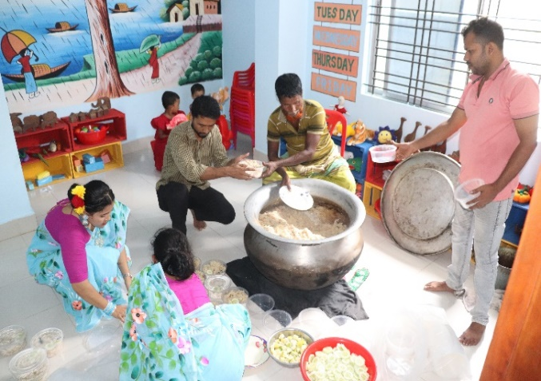
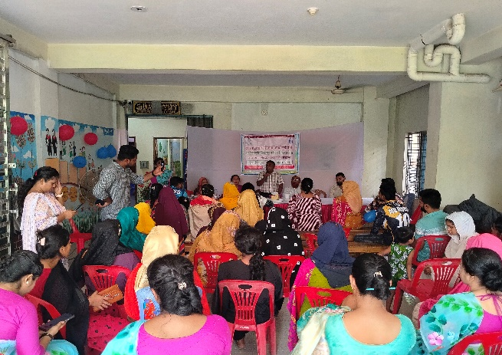
5.3 Children’s Gathering and Food Festival:
On 26 September 2025, Caritas Joyful and Kindergarten Project organized a Children’s Gathering and Food Festival with the participation of children and their parents. The Educators and the Care Givers of the project also attended. Various officials from government and non-government institutions, social workers, local dignitaries, children, parents, as well as project officers were present at the event. The total number of participants was 103 (men 25, women 58, and children -20).The program was conducted by the Field Officer of Caritas Joyful Kindergarten. The Upazila Sub-Assistant Agriculture Officer, Mr. Suman Ahmed, attended the event as the chief guest. The gathering was lively and festive. A drawing competition was organized for the children and games for the parents. Prizes were arranged for every child. Everyone enjoyed the occasion together.

At the event, Mr. Suman Ahmed said, “Caritas has taken a very good initiative for the children of garment workers in this area, as many parents work all day in various factories and have no one to look after their children. In the Caritas Day Care Centre, the children can stay safely. They are learning to study and are being prepared for schooling through play. They are also learning various moral values. The children wash their hands with soap before eating. In addition, their mental and intellectual development is being ensured through different child-friendly activities. Especially, the environment of Joyful Kindergarten is very beautiful and child-friendly, and the staffs are very caring and hardworking.”
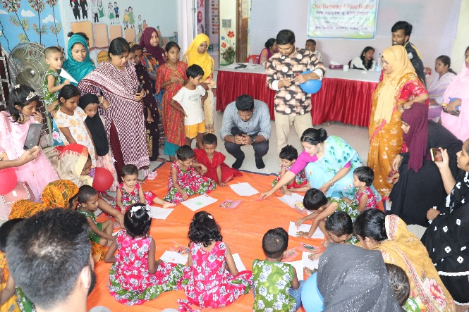
The children at the day care will learn many things that will be useful in their future school and family life. In addition, Caritas is also working to raise awareness within the community. Their activities include promoting early childhood care and development, cleanliness and hygiene, celebration of various special days, proper cooking methods that preserve the nutritional value of food, and awareness about food and child nutrition. As a result of these awareness programs, community members are becoming more informed, and at the same time, employment opportunities for parents are being ensured. Special thanks were extended to the donor organizations for their financial support for this initiative.
In the next part of the event’s discussion session, 20 kindergarten children participated in a drawing competition. There were also fun games such as a pot-breaking contest for fathers and a musical chair game for mothers. At the end of the day-long event, the honourable chief guest distributed prizes among the children and parents. The children spent a joyful day with their parents at the kindergarten and were very happy.

Opinion from Parents:

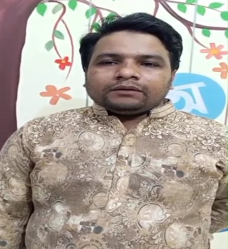
Opinion of Arafat’s Father (Ilias):
Assalamu Alaikum. My name is Ilias. My son, Arafat, is a regular child at Joyful Day Care Center. I am very happy to share that children at Joyful Day Care receive education in a very caring and supportive environment. They learn rhymes, stories, and participate in various educational activities, which play an important role in their mental and intellectual development.
My son happily shares with us what he learns at the center when he returns home, which makes us very proud. It shows that he is becoming more interested in learning.
Joyful Day Care is not just a learning center; it is a great support and blessing for parents like us. The center gives high importance to children’s safety, care, and quality education.
I would like to express my sincere gratitude to all the teachers and staff of Joyful Day Care. Thank you, Joyful Day Care.
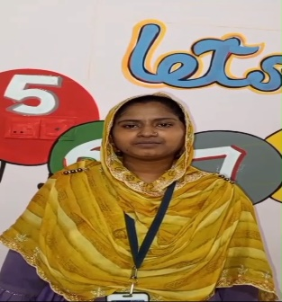
Opinion of Tamim’s Mother (Ripa Akter):
Assalamu Alaikum. My name is Ripa. My child’s name is Rayain, and he is a children at Joyful Day Care Center. I am very satisfied that my child is growing up in a nice and safe environment here.
At the daycare center, children regularly engage in studies, play, and various creative activities, which support their overall development. My child receives great care and affection here, which is very important for me as a parent.
Additionally, the center provides nutritious food for the children and ensures that they get proper rest and sleep regularly. Overall, Joyful Day Care plays a significant role in the physical, mental, and social development of children.
I would like to sincerely thank all the teachers and staff of Joyful Day Care for their dedication and care.

6. Community Engagement:
6:1: Engagement of Community:
SL | Events | Target | Achievements | Remarks
1 | Social Group Meeting | 16 | 16 (100%)
2 | Adolescents Group meeting | 5 | 5 (100%)
3 | Child Group meeting | 6 | 6 (100%)
4 | Cooking method Demonstration | 2 | 2 (100%)
5 | Day Observation | 4 | 4 (100%)

6:2: Types of Events Organised:
Group Meeting (Social, Adolescents and Child):
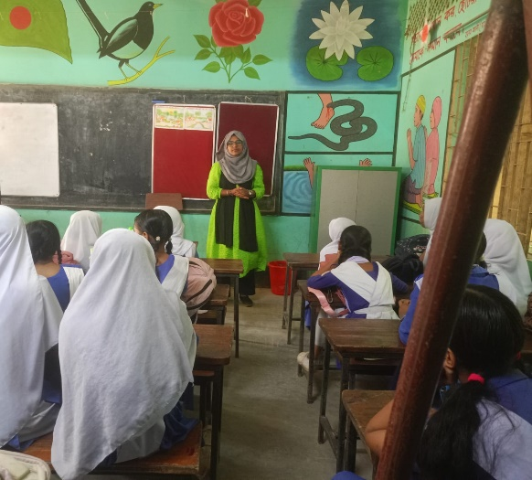
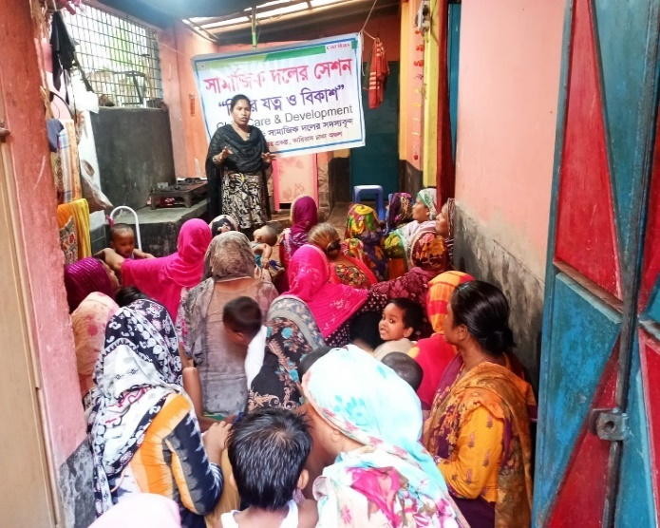
In the area of Joyful Day-Care and Kindergarten, social groups, adolescent groups (boys and girls), and children’s groups have been formed. In the working areas of Taiyabpur and Jirabo, a total of 16 meetings and sessions were organized with the social groups, attended by 256 participants, all of whom were women. Among them, 99 were local community members.
The key discussion topics of these sessions included: child enrollment in the center, child care, the nutritional value of vegetables and fruits, the benefits of eggs, fish, and meat, the nutritional properties of leafy greens such as jute leaves and stem amaranth, balanced diet, cooking methods that help retain nutritional value, vegetable seedling plantation techniques, preparation of organic fertilizers, making of play materials, handwashing, personal hygiene and cleanliness, child protection, dos and don’ts with children, and collecting rhymes and stories.
In the adolescent groups, discussions were held on personal hygiene, adolescence, safeguarding, child protection, and nutrition. A children’s group has also been formed in the community, where activities are conducted to support their protection and development through sessions on good touch and bad touch, songs, rhymes, and games.
As a result of participating in these sessions, relationships among the members have strengthened. They now keep in touch with one another, maintain personal cleanliness, and have become more aware of child care. Regular hand washing with soap has become a habit. Members are also assisting in enrolling children at the center, growing vegetables in their home yards, and cooking food in covered pots to preserve nutritional value.

Cooking Method Demonstration

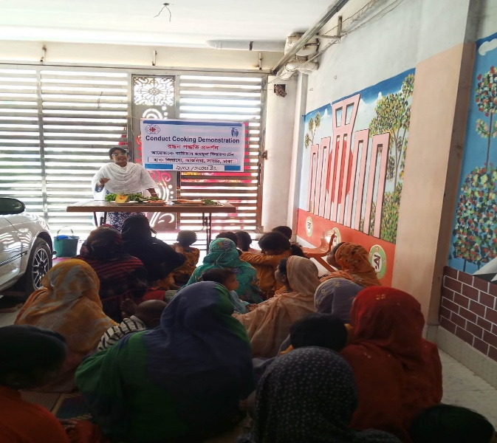
Two cooking demonstration was organized in the premises of Caritas Joyful Day-care and Kindergarten, presenting the process of cooking vegetables while preserving their nutritional value. A total of 157 participants attended the event. Among them 137 were women, 20 men,
Participants were informed about proper nutrition and healthy cooking practices:
- Vegetables should be cleaned and washed with water before cutting.
- Cooking should be done on medium heat.
- Salt should be added five minutes before finishing the cooking.
- Food should be chewed properly while eating.
They were also advised to eat leafy vegetables along with lemon and green chilli to increase nutritional value.
Families in the community are now following these cooking methods to ensure better nutrition for all members.

National and International Day Observance:
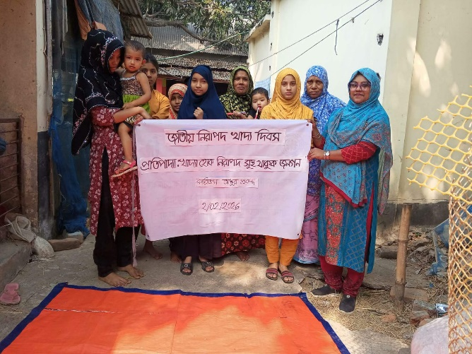
On 20/11/2025, World Children’s Day was celebrated. A total of 48 children participated, including 19 children from the daycare center and 29 children from the community. Drawing and cultural activities were organized for the children, which brought them great joy and engagement.

On 02/02/2026, National Safe Food Day was observed at the house of Ali Azgar in Mollahpara, Toiyabpur village, within the community area of Joyful Daycare and Kindergarten School. The theme of the event was “Safe Food for a Healthy Nation.” A total of 42 participants attended. The importance of food safety was discussed in detail.

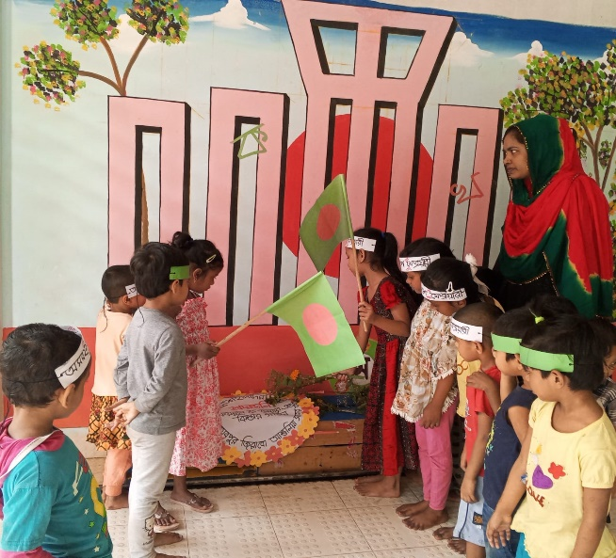

On 21/02/2026, International Mother Language Day and Martyrs’ Day were observed at the daycare center premises. A total of 19 children from the daycare participated in the program.
Through these activities, members of the community social group have been able to understand the importance of observing different special days, and their awareness has increased significantly.

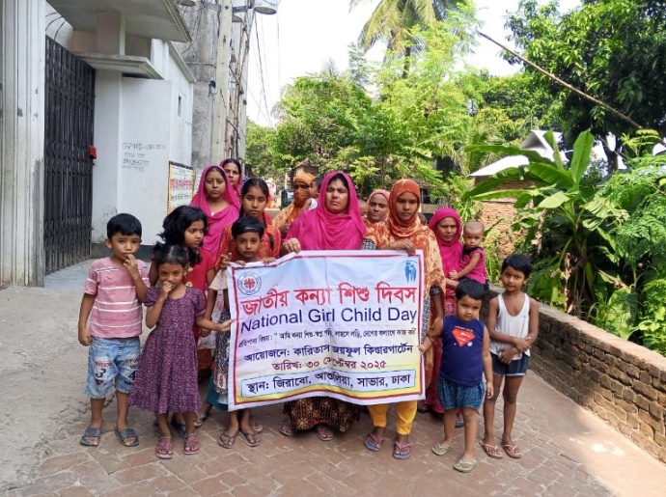
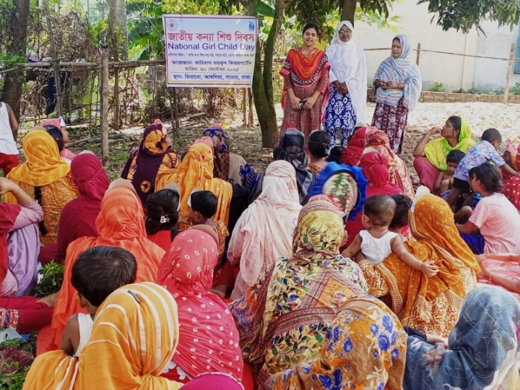
National Girl Child Day Celebration:
Under the main theme “I am a girl child, I dream, I fight with courage, and I work for the welfare of the country,” the National Girl Child Day was celebrated on 30 October 2025 in the Taiyabpur Mollapara area, organized by Caritas Joyful Day-care and Kindergarten. The celebration began at 10:30 AM with the participation of members of the local social group. Participants started a rally from Joyful Day-care and Kindergarten, which moved through Taiyabpur and concluded at Mollapara. After the rally, a discussion meeting was held. A total of 62 people participated in the event, including 31 women, 5 men, 6 boys, and 8 girls.

Two members of the participating social group expressed their opinions and feelings. They said that nowadays, we are creating opportunities and environments for girl children to study, play, and develop their talents so that they can become doctors, lawyers, engineers, barristers, or pilots in the future. Everyone agreed with this idea. They further said, “We could not study ourselves, and as a result, we have missed out on understanding many things. Our expectation is that our daughters will be able to study, become good human beings, and contribute to the development of society. We will ensure that they have the opportunity to attend school, participate in sports, and develop their talents. We will provide them with a safe environment to grow up in, and we will not marry them off at an early age. This is our commitment.”

6.2: Feedback from the Community:
Opinion of social group’s member (Sakila) :

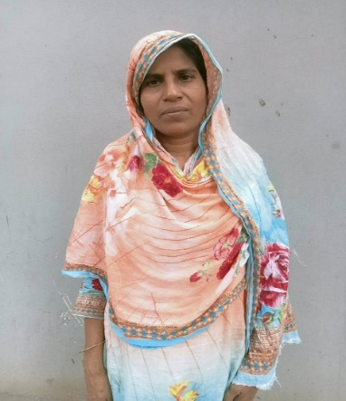
Assalamu Alaikum. My name is Sakila. I am a member of the Padma group. We have a daycare center here where children are taught. We attend meetings regularly. We have been taught about personal hygiene. After using the toilet, we wash our hands with soap and wear shoes when going to the toilet. The children are well taken care of here. Nutritious food is provided every week, such as noodles, milk, eggs, porridge, and fruits. The children are bathed daily, and they are kept clean using soap and shampoo. If any child becomes sick, they receive treatment and medicine. The caregivers take care of the children like mothers.

Opinion of social group’s member (Champa Akter):
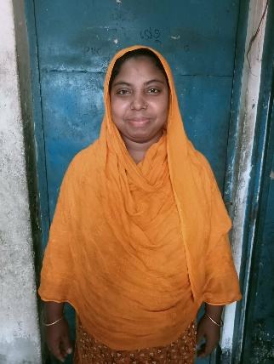
I am Champa Akter, a proud member of the Shapla group, where I regularly participate in social group meetings. These meetings have been very helpful in improving my knowledge about health, hygiene, and proper cooking practices. Through these sessions, I have learned many important things that I now apply in my daily life.
One of the key lessons I have learned is about the proper way to handle and cook vegetables. I now understand that vegetables should always be washed thoroughly before cutting. This helps remove dirt, germs, and harmful chemicals from the surface, ensuring that the food we eat is safe and healthy.
I have also learned that vegetables should be cooked on low heat and kept covered while cooking. Cooking on low heat helps to preserve the natural nutrients, color, and taste of the vegetables. Keeping the pot covered prevents the loss of vitamins and ensures that the food cooks evenly.
Another important practice I follow is adding salt just before taking the vegetables off the stove. This helps maintain the natural quality and nutritional value of both the vegetables and the salt. It also improves the taste without overcooking or reducing the effectiveness of nutrients.
In addition, I always make sure to keep cooked food covered. This protects the food from dust, insects, and contamination, keeping it safe for consumption.
By following these practices, I am able to prepare healthier meals for myself and my family. The knowledge I gained from the Shapla group has brought positive changes in my cooking habits and overall lifestyle.

Opinion of social group’s member (Momena):
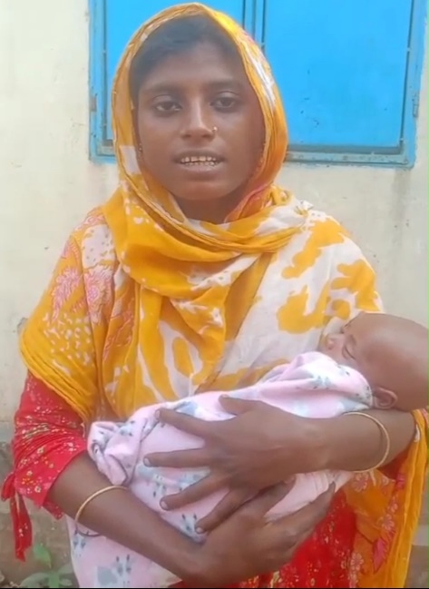
Assalamu Alaikum. My name is Momena, and I am a member of the Joba group. I would like to share my experience and learning from the sessions I have attended.
Through these group meetings, we have been taught important information about the care of pregnant mothers and young children. I have learned in detail about the types of nutritious foods I should eat to keep both myself and my unborn baby healthy, such as a balanced diet including vegetables, fruits, protein, and adequate water. This knowledge has helped me become more conscious about my daily food intake and overall health.
In addition, I have learned about the danger signs during pregnancy. For example, if I experience dizziness, unusual bleeding, high fever, severe headache, or convulsions, I now understand that these are serious warning signs, and I should seek medical care immediately. Before attending these sessions, I was not fully aware of these risks and what actions to take.
As a pregnant woman, these meetings have been very helpful for me. I have gained confidence and awareness about how to properly take care of myself during pregnancy. I now follow the advice provided in the sessions and try to maintain a healthy lifestyle.
As a result, I feel better prepared and more secure about my pregnancy. Currently, both I and my newborn baby are well. I am very grateful for the knowledge and support I have received from the Joba group.

7: Staff Development of the team:
SL | Subject | Target | Achievements | Remarks
1 | Project Orientation and Self -Development Training (persons) | 10 | 10 (100%)
2 | Session on preparing report (persons) | 5 | 5(100%)
3 | Session on Developing ECD materials & toys | 5 | 5(100%)
4 | Session on Child Protection & Safeguarding | 5 | 5(100%)

Educational Sessions for Staff:
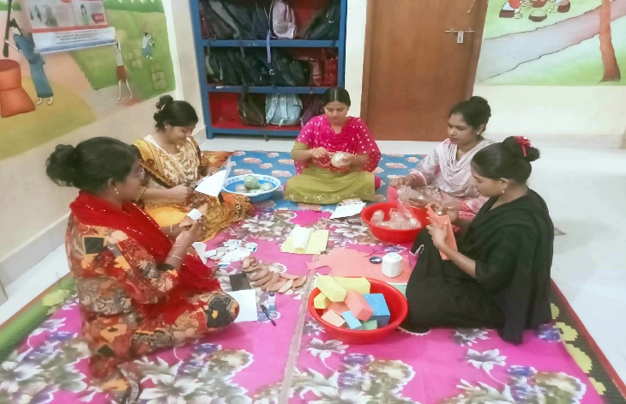
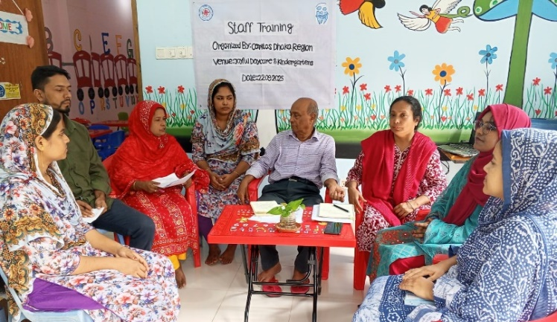
To ensure the care, growth, and development of children at Caritas Joyful Kindergarten, orientation and educational sessions have been provided for the staff. The sessions covered topics such as safeguarding and child protection, child rights, appropriate and inappropriate behavior with children, and training on making different types of toys to support children’s development. Staff members are now effectively using self-made materials and toys to help children learn through play. In addition, they are teaching children through self-created stories and rhymes on various topics such as nature and environment, fairy tales, and vegetables. These activities have contributed significantly to enhancing the staff’s skills and teaching capacity.

