Caritas Bangladesh
Joyful Day care & Kindergarten Project
Six -Monthly Progress Report
https://limewire.com/d/vpT2b#2A4MBubauo

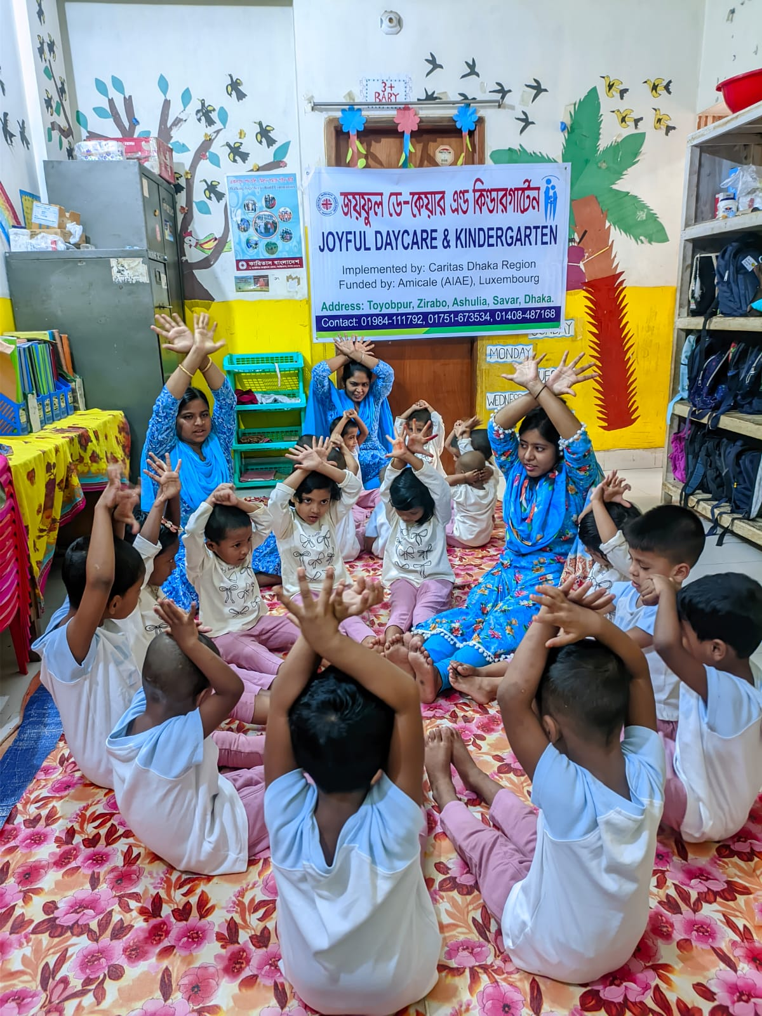

Reporting Period: From: 01-04-2025 to: 30-09-2025
Centre Name: Joyful Day Care and Kindergarten
Region: Caritas Dhaka Region
Name of the Donor organisation: AIAE-Luxembourg
Date of Submission: 28-10-2025

1General Information:
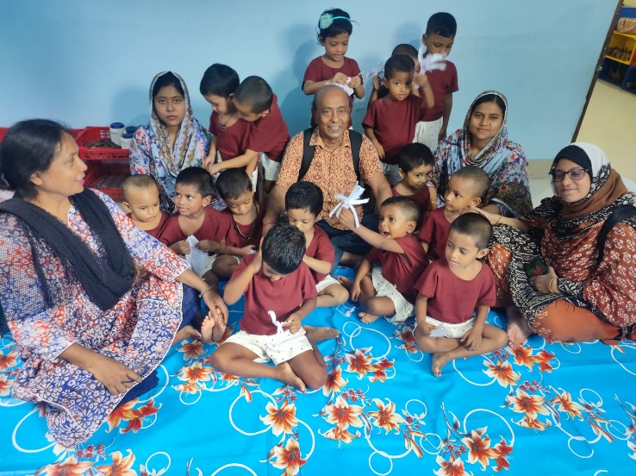
Introduction:
Caritas Dhaka Region is working with children, parents, and the community through the “Joyful Day-Care and Kindergarten” project to ensure the safety and development of children of low-income working mothers living in the industrial areas of Ashulia, under Savar Upazila of Dhaka District. The project focuses on the care, growth, and development of children whose parents work in various garment factories. They belong to the marginalized groups. Through playful learning activities, children are being prepared for school. They are supported to develop socially, physically, intellectually, linguistically, and emotionally through different child-friendly games and activities.
1.1. Enrolment:
Gender | Previous | Current(during the reporting period) | Cumulative (2+3) | Comments (if any)
1 | 2 | 3 | 4 | 5
Boys | 0 | 21 | 21
Girls | 0 | 11 | 11
Total | 0 | 32 | 32

1.2. Dropout:
Gender | Previous | Current | Cumulative (2+3) | Comments (if any)
Boys | 0 | 08 | 08 | Note -below
Girls | 0 | 04 | 04
Total | 0 | 12 | 12

Note: During the reporting period, 32 children were enrolled and 12 children dropped out. As of September 2025, the number of children stands at 20.

Reasons of drop out:
- Due to the closure of garments and factory work, the parents of the children became unemployed and fell into financial hardship. As a result, they moved back to their village with their families.
- The child’s parents changed jobs and left the area. Because the daycare and kindergarten are far away, they could not enroll their child there.
- Due to family conflict and quarrels, the child’s parents have been separated, and the mother has moved elsewhere with the child.

Actions Taken to Minimize Dropout:
- New families who have moved into the area have been informed about the daycare and kindergarten services.
- The child survey work is ongoing. Parents have been provided with information about job opportunities in various garments and factories and are being connected to potential employers. If they are employed, they can send their children to the center.
- They are being assisted to look for jobs while keeping their children at the daycare center.
- Parents have also received counseling on family matters. They have been made aware that family separation hinders a child’s development. This needs extra care but due to staff shortage, it remains unattended (community mobilization-gender based violence).

3. Attendance:
Gender | Previous | Current | Comments (if any)
Boys | 0 | 13.0
Girls | 0 | 7.3
Total | 0 | 10.15 | Attendance on average is 10.15

During the reporting period, the register maintained reveals that attendance figures in the class varied from the highest 14 to the lowest 12 in case of boys while that varied from the highest 10 to the lowest 6 in case of girls. The average figure accounted for 10.15.

4. Children Development Assessment:
Development Area | No. Assessed (Boys / Girls) | Indicator | Previous (%) | Current (%)
Puzzle Completion | Boys: 09 | % completed independently | 0 | 43%
Puzzle Completion | Girls: 05 | % completed independently | 0 | 45%
Stacking Blocks | Boys: 10 | % completed independently | 0 | 48%
Stacking Blocks | Girls: 06 | % completed independently | 0 | 55%
Expressing Needs/Experiences | Boys: 08 | % expressed independently | 0 | 38%
Expressing Needs/Experiences | Girls: 05 | % expressed independently | 0 | 45%
Social Play & Group Interest | Boys: 09 | % participated independently | 0 | 43%
Social Play & Group Interest | Girls: 06 | % participated independently | 0 | 55%
Emotional Regulation | Boys: 04 | % controlled impulses | 0 | 19%
Emotional Regulation | Girls: 05 | % controlled impulses | 0 | 45%
Physical Activities (Running, Jumping, etc.) | Boys: 10 | % performed independently | 0 | 48%
Physical Activities (Running, Jumping, etc.) | Girls : 06 | % performed independently | 0 | 55%

Puzzle Completion: Among 21 boys, 9 boys can match flowers, fruits, vegetables, and fish. Among 11 girls, 5 girls can match flowers, fruits, vegetables, and fish.
Stacking Blocks:Among 21 boys, 10 boys (47.61%) can build houses, roads, rivers, cars, and bridges. Among 11 girls, 6 girls (54.54%) can build houses, roads, rivers, cars, and bridges.
Expressing Needs/Experiences: Among 21 boys, 8 boys can go to the toilet by themselves, express when they are hungry, help in serving food plates, help in making the bed, express when they need a bath, and talk about play activities. Among 11 girls, 5 girls can go to the toilet by themselves, express when they are hungry, help in serving food plates, help in making the bed, express when they need a bath, and talk about play activities.
Social Play & Group Interest: Among 21 boys, 9 boys can play instruction-based games such as “Tree flies–bird flies,” pond side game, hiding crops game, morning circle, balancing games, and imaginative play. Among 11 girls, 6 girls can play instruction-based games such as “Tree flies–bird flies,” pond side game, hiding crops game, morning circle, balancing games, and imaginative play.
Emotional Regulation: Among 21 boys, 4 boys are able to control their emotions — for example, they do not cry, act stubborn, fight, and they share toys and play with others. Among 11 girls, 5 girls are able to control their emotions — for example, they do not cry, act stubborn, fight, and they share toys and play with others.
Physical Activities (Running, Jumping, etc.): Among 21 boys, 10 boys participate in various games such as throwing the ball, acting through gestures, crossing the river with a basket on the head, counting games, role play, finger rhymes, and in-out games. Among 11 girls, 6 girls participate in various games such as throwing the ball, acting through gestures, crossing the river with a basket on the head, counting games, drama, finger rhymes, in-out games, and all types of children’s play activities.

5. Parents’ Engagement: (Meetings//Seminars/Demonstration):

SL | Events Held | Target | Achievements | Remarks
1 | Parents Meeting | 6 | 6
2 | ECD Awareness Seminar | 1 | 1
3 | Child Gathering & Food Festival | 1 | 1
4 | % of Parents Attended | 90% | 75% | Total number of parents:40

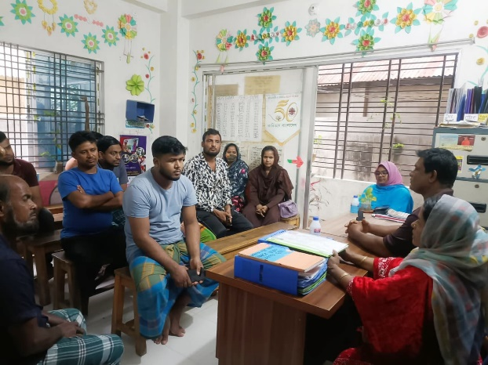
5.1 Parents Meeting and Discussion Session:
Joyful Kindergarten organized a parents’ meeting every month, and a total of six meetings held so far. In these meetings, areas of discussions covered for example- child care, growth and development, child protection and safeguarding, child nutrition and balanced diet, cooking methods that preserve nutritional value, personal hygiene, water and sanitation, and children’s education. The meetings also included discussions on appropriate and inappropriate behavior towards children to ensure their safety and protection. Additionally, awareness sessions were conducted to help parents build friendly and strong relationships with their children, thereby strengthening family bonds. Parents expressed their feelings by saying that their children are happy and safe here. The caregivers love and take great care of the children. They also mentioned that attending the parents’ meetings makes them feel very happy. By keeping their children at the daycare, they can work peacefully throughout the day without worry. During the meetings, the children’s status files are shared with the parents. Joyful Day Care and Kindergarten is working hard for the care and development of the children. All the parents expressed their gratitude to the donor organization, saying that they hope their children can continue receiving these services for a long time. This support allows them to keep their children close while also improving their family’s financial situation.

5.2 ECD Awareness Seminar:
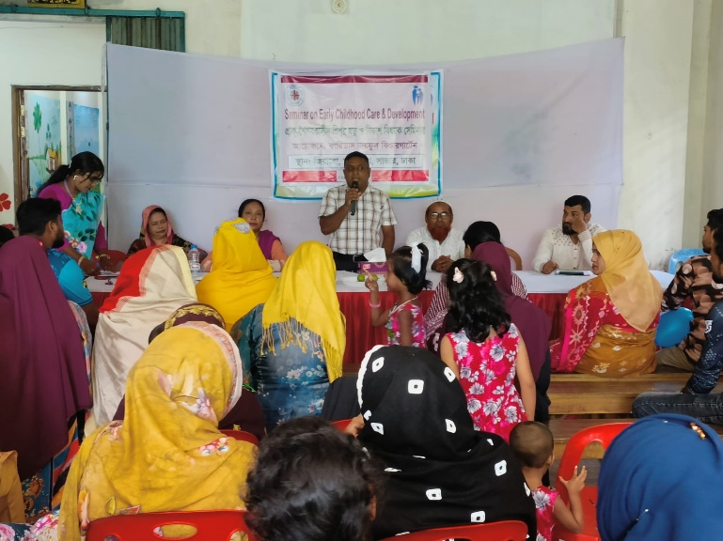
On September 26, 2025, a seminar on Early Childhood Care and Development was organized for the parents of the children. All the 40 parents participated (100%) in the event. It has been made possible to hold the event on holiday. The seminar focused on discussions about the care and development of early childhood. Caritas Joyful Day Care and Kindergarten serve as a centre that provides care for children and prepares them for school. This kindergarten offers a safe and stimulating environment where children can learn and grow. It ensures various aspects of their social, emotional, physical, mental, and intellectual development. In addition, each child at the kindergarten has the opportunity to interact with peers of different ages, which helps them develop co-operation, friendship, and social communication skills. Through different play materials and activities, children enhance their basic numeracy, letter recognition, and language skills. Under the supervision of Caritas Joyful Day Care, these activities encourage imagination and creativity among children. At the kindergarten, children learn to express their feelings and develop empathy for others, which strengthen their confidence and independence. In a positive and secure environment, they can learn new things without fear. To ensure proper nutrition, the children are provided with healthy meals including seasonal fruits, fish, meat, and vegetables, which play a vital role in their physical and mental development. Physical play and exercises also help improve their strength, endurance, coordination, and overall well-being.
Joyful Kindergarten is truly a special place for early childhood development. It plays an essential role in promoting children’s social, emotional, physical, mental, and intellectual growth. When children grow up in a safe and nurturing environment, it lays a strong foundation for their future.

5.3 Children’s Gathering and Food Festival:
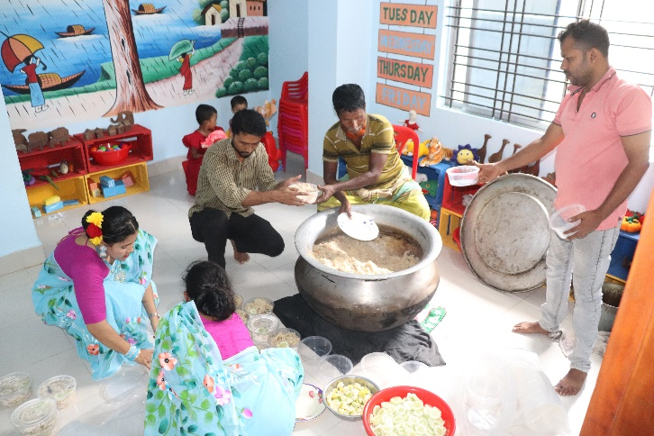
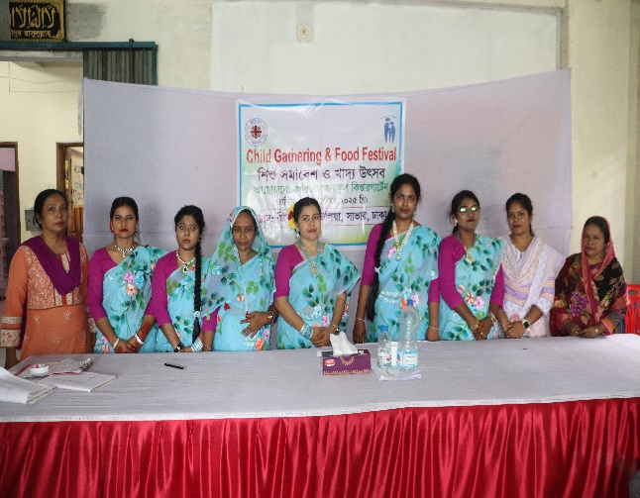
On 26 September 2025, Caritas Joyful and Kindergarten Project organized a Children’s Gathering and Food Festival with the participation of children and their parents. The Educators and the Care Givers of the project also attended. Various officials from government and non-government institutions, social workers, local dignitaries, children, parents, as well as project officers were present at the event. The total number of participants was 103 (men 25, women 58, and children -20).The program was conducted by the Field Officer of Caritas Joyful Kindergarten. The Upazila Sub-Assistant Agriculture Officer, Mr. Suman Ahmed, attended the event as the chief guest. The gathering was lively and festive. A drawing competition was organized for the children and games for the parents. Prizes were arranged for every child. Everyone enjoyed the occasion together.
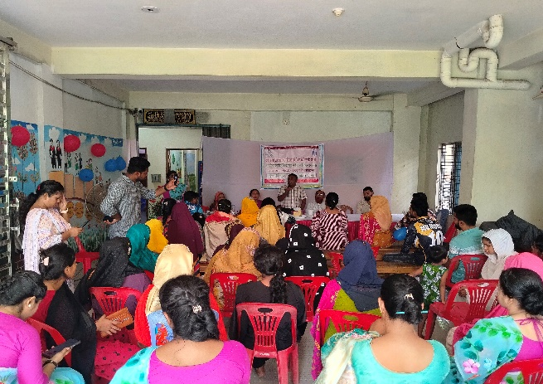
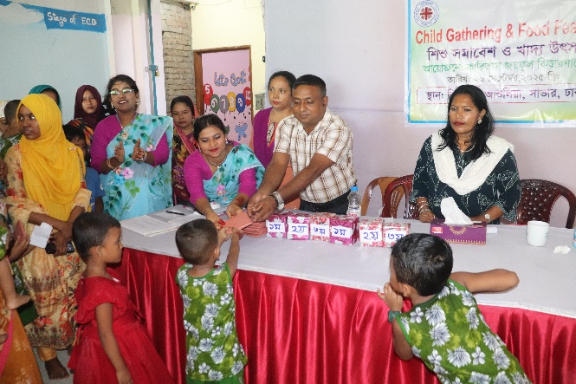
At the event, Mr. Suman Ahmed said, “Caritas has taken a very good initiative for the children of garment workers in this area, as many parents work all day in various factories and have no one to look after their children. In the Caritas Day Care Centre, the children can stay safely. They are learning to study and are being prepared for schooling through play. They are also learning various moral values. The children wash their hands with soap before eating. In addition, their mental and intellectual development is being ensured through different child-friendly activities. Especially, the environment of Joyful Kindergarten is very beautiful and child-friendly, and the staffs are very caring and hardworking.”
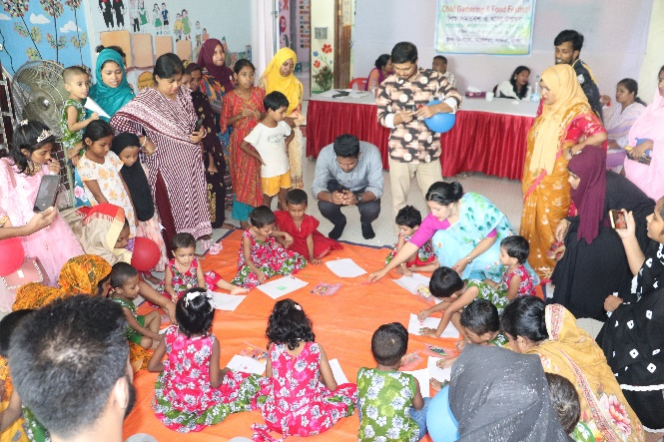
The children at the day care will learn many things that will be useful in their future school and family life. In addition, Caritas is also working to raise awareness within the community. Their activities include promoting early childhood care and development, cleanliness and hygiene, celebration of various special days, proper cooking methods that preserve the nutritional value of food, and awareness about food and child nutrition. As a result of these awareness programs, community members are becoming more informed, and at the same time, employment opportunities for parents are being ensured. Special thanks were extended to the donor organizations for their financial support for this initiative.
In the next part of the event’s discussion session, 20 kindergarten children participated in a drawing competition. There were also fun games such as a pot-breaking contest for fathers and a musical chair game for mothers. At the end of the day-long event, the honourable chief guest distributed prizes among the children and parents. The children spent a joyful day with their parents at the kindergarten and were very happy.

Feedback from Parents:

Opinion of Rupa: https://limewire.com/d/TqVS2#SZ7UQ0HH1c

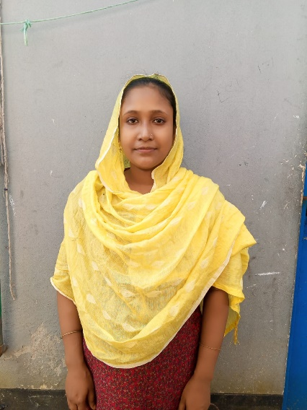
My name is Rupa. Cynthia is my daughter. I am able to work nicely because I can keep my daughter at Joyful Daycare. Everyone here takes very good care of our children, even better than we do ourselves. They also teach and help our children with their studies. If there were more Joyful Day care centres in other areas, it would have been more helpful for other vulnerable parents. Because of the day care, we can work with peace of mind. I am a poor and helpless person, and we have to earn our living through hard work. That’s why Joyful Daycare is a great blessing for us.
I also wish well for those who take care of our children, may they always stay well. This is truly a blessing for us. We cannot give enough time to our children, but the educators at the day care for them with even more love and attention than we can. They keep our children in a safe and beautiful environment. I sincerely thank Joyful Day care and Kindergarten for providing such opportunities and facilities.

Opinion of Samina : https://limewire.com/d/OY1mp#b2MmTEwVNo
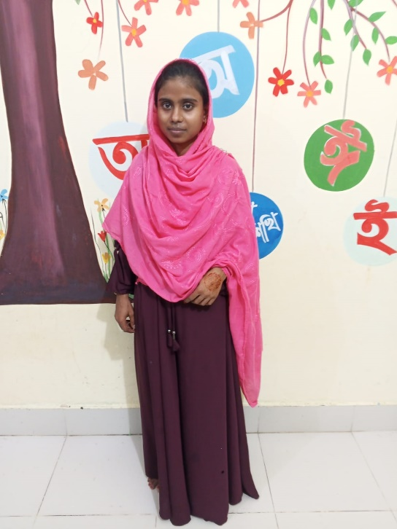
I am Mosammat Samina. My daughter’s name is Sabina. I came to Dhaka city because of financial hardship. Everyone comes to Dhaka for the same reason — to earn a living. I wanted to find a job, but I had a problem — I had a child, and there was no one to look after her. I searched for work and finally got a job, but I couldn’t find any place to keep my daughter. Then, one of my neighbors told me about a daycare center. I found out about Joyful Day Care and saw that it was very good. I felt confident and decided to keep my child there.

After enrolling her, I saw great improvement. They take good care of the children and provide them with food. Before, my daughter used to play outside in the dust and dirt and wouldn’t listen to me. Now, she listens when I tell her something. She bathes in time and eats in time. After keeping her in daycare, I can work peacefully and earn money. At the daycare, they give the children nutritious food and milk. Now, when my daughter comes home, she behaves much better than before. She doesn’t touch dirt or garbage anymore and stays neat and clean. Earlier, she used to waste food, but now she eats properly without spilling.
That’s why I am deeply grateful to Joyful Day Care. If centers like this could be established in more areas of Ashulia, many mothers like me would be greatly benefited.

6. Community Engagement:
6:1: Engagement of Community:
SL | Events | Target | Achievements | Remarks
1 | Social Group Meeting | 8 | 8(100%)
2 | Adolescents Group meeting | 1 | 1(100%)
3 | Child Group meeting | 1 | 1(100%)
4 | Cooking method Demonstration | 1 | 1(100%)
5 | Day Observation | 1 | 1(100%)

6:2: Types of Events Organised:
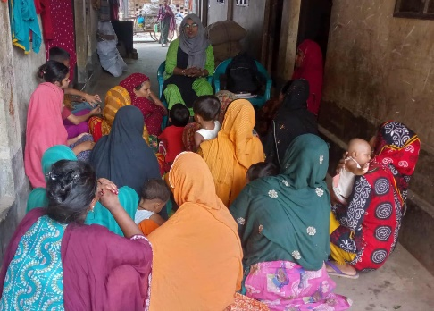
Group Meeting (Social, Adolescents and Child):
In the area of Joyful Day-Care and Kindergarten, social groups, adolescent groups (boys and girls), and children’s groups have been formed. In the working areas of Taiyabpur and Jirabo, a total of 8 meetings and sessions were organized with the social groups, attended by 120 participants, all of whom were women. Among them, 57 were local community members.
The key discussion topics of these sessions included: child enrollment in the center, child care, the nutritional value of vegetables and fruits, the benefits of eggs, fish, and meat, the nutritional properties of leafy greens such as jute leaves and stem amaranth, balanced diet, cooking methods that help retain nutritional value, vegetable seedling plantation techniques, preparation of organic fertilizers, making of play materials, handwashing, personal hygiene and cleanliness, child protection, dos and don’ts with children, and collecting rhymes and stories.
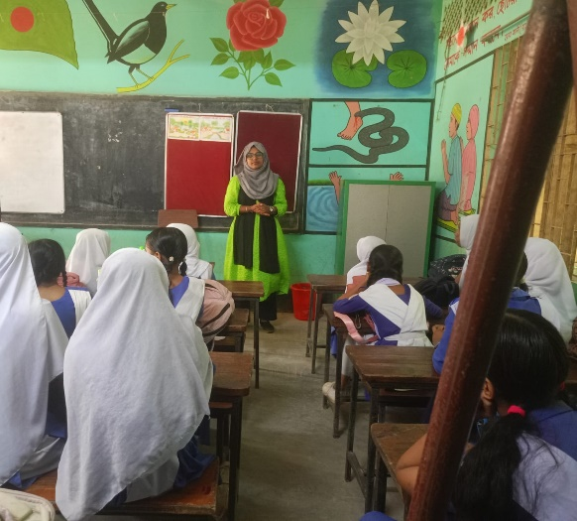
In the adolescent groups, discussions were held on personal hygiene, adolescence, safeguarding, child protection, and nutrition. A children’s group has also been formed in the community, where activities are conducted to support their protection and development through sessions on good touch and bad touch, songs, rhymes, and games.
As a result of participating in these sessions, relationships among the members have strengthened. They now keep in touch with one another, maintain personal cleanliness, and have become more aware of child care. Regular hand washing with soap has become a habit. Members are also assisting in enrolling children at the center, growing vegetables in their home yards, and cooking food in covered pots to preserve nutritional value.

Cooking Method Demonstration
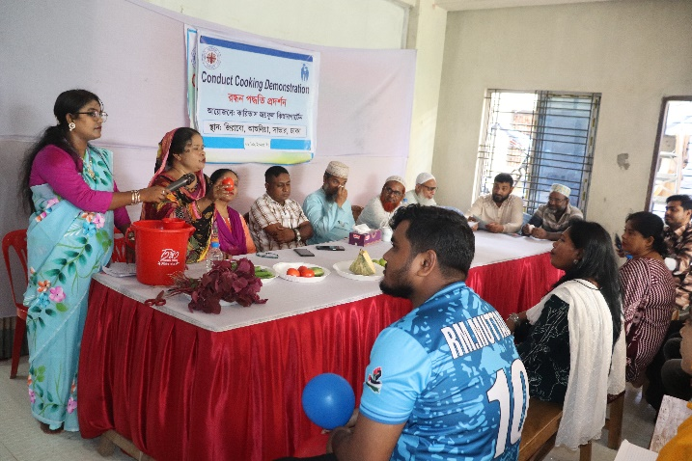
A cooking demonstration was organized in the premises of Caritas Joyful Day-care and Kindergarten, presenting the process of cooking vegetables while preserving their nutritional value. A total of 53 participants attended the event. Among them 23 were women, 15 men, 7 boys, and 8 girls.
Participants were informed about proper nutrition and healthy cooking practices:
- Vegetables should be cleaned and washed with water before cutting.
- Cooking should be done on medium heat.
- Salt should be added five minutes before finishing the cooking.
- Food should be chewed properly while eating.
They were also advised to eat leafy vegetables along with lemon and green chilli to increase nutritional value.
Families in the community are now following these cooking methods to ensure better nutrition for all members.
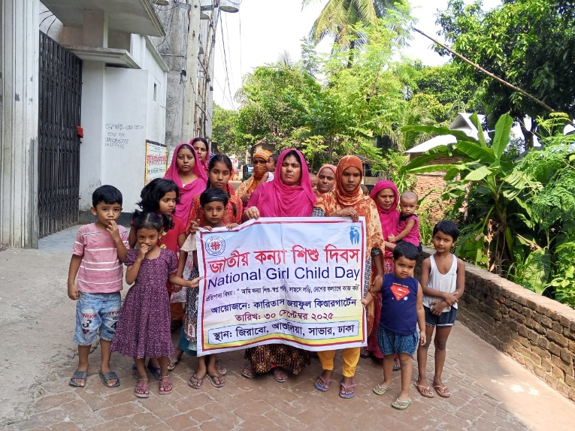
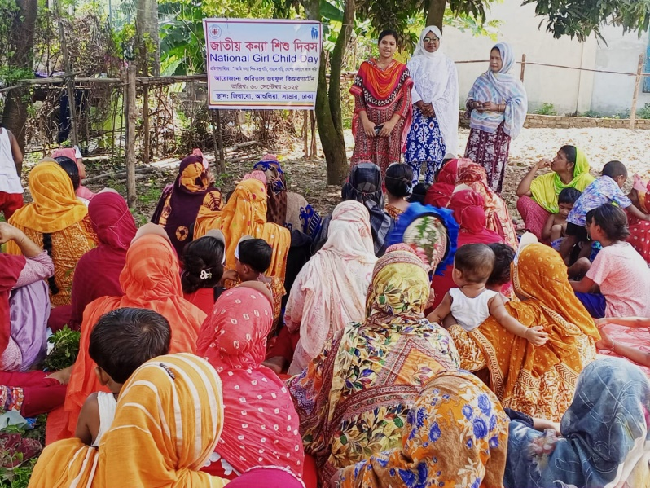
National Girl Child Day Celebration : https://limewire.com/d/8ZKzz#P8KWGjrJK8

Under the main theme “I am a girl child, I dream, I fight with courage, and I work for the welfare of the country,” the National Girl Child Day was celebrated on 30 October 2025 in the Taiyabpur Mollapara area, organized by Caritas Joyful Day-care and Kindergarten. The celebration began at 10:30 AM with the participation of members of the local social group. Participants started a rally from Joyful Day-care and Kindergarten, which moved through Taiyabpur and concluded at Mollapara. After the rally, a discussion meeting was held. A total of 62 people participated in the event, including 31 women, 5 men, 6 boys, and 8 girls.

Two members of the participating social group expressed their opinions and feelings. They said that nowadays, we are creating opportunities and environments for girl children to study, play, and develop their talents so that they can become doctors, lawyers, engineers, barristers, or pilots in the future. Everyone agreed with this idea. They further said, “We could not study ourselves, and as a result, we have missed out on understanding many things. Our expectation is that our daughters will be able to study, become good human beings, and contribute to the development of society. We will ensure that they have the opportunity to attend school, participate in sports, and develop their talents. We will provide them with a safe environment to grow up in, and we will not marry them off at an early age. This is our commitment.”
6.2: Feedback from the Community:
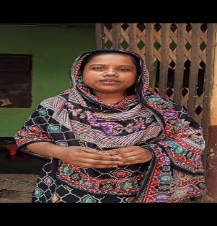
Rumana.: https://limewire.com/d/5Bfqv#f7rS1Nopvq
Assalamu Alaikum, My name is Rumana. I am a member of the Padma group. We are invited to attend meetings, and we go regularly. In the meetings, we have learned many things. These meetings have brought a lot of positive changes in our lives, and we are doing much better now. Before, we didn’t wash our hands with soap — we only used water. But after attending the meetings, we now wash our hands with soap before eating. Earlier, we didn’t use shoes in the toilet, but now we do. Compared to before, all our family members are healthier and doing well. On behalf of the Padma group, thank you.
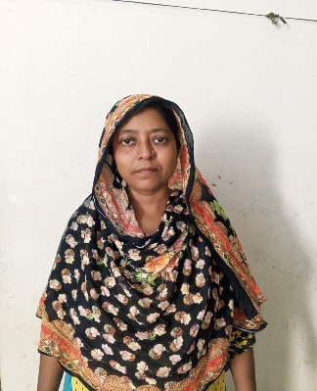
Sherin Begum.: https://limewire.com/d/dFZUT#XxUDPPxE6G
My name is Sherin Begum. I am a member of the social group. We have meetings every month, and we attend those meetings regularly. There were many things we didn’t know before, but after coming here, we have learned a lot, for example, how to grow vegetables and how to get nutritious food. We have also learned how to plant trees in soil inside old buckets or sacks. We have grown various vegetables such as spinach, bottle gourd, chili, eggplant, and many others. By growing vegetables in buckets or sacks, we not only eat them ourselves but also sell some to support our household.
Anjana. : https://limewire.com/d/1ztF5#gDgiGim55u
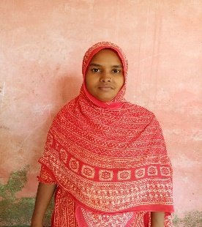
My name is Anjana. I am a member of the Joba group. Before, I didn’t know how to cut and cook vegetables properly. After coming here, I learned how to cut and cook vegetables the right way. Earlier, I didn’t eat vegetables, but now, after learning, everyone in my family eats them. Before, I used to cut vegetables into small pieces and then wash and cook them. Now, I wash them first, cut them into larger pieces, and cook them covered.
Khadija: https://limewire.com/d/bjCO1#ioiB0ID3Gn
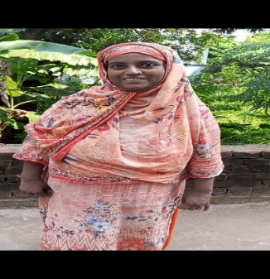
Assalamu Alaikum, my name is Khadija. I am a member of the Golap group. Meetings are held here every month, and I attend them regularly. After coming to the meetings, I have learned many things — such as how to eat nutritious food, how to cook vegetables properly, how to stay healthy without taking medicine, how to control diabetes without medicine. Now, by the grace of Allah, I am much more in control of my health and feel well without depending on medicine. I have learned a great deal after joining here. On behalf of the Golap group, thank you.
7: Staff Development of the team:
SL | Subject | Target | Achievements | Remarks
1 | Project Orientation and Self -Development Training (persons) | 10 | 10 (100%)
2 | Session on preparing report (persons) | 5 | 5(100%)
3 | Session on Developing ECD materials & toys | 5 | 5(100%)
4 | Session on Child Protection & Safeguarding | 5 | 5(100%)

Educational Sessions for Staff:
To ensure the care, growth, and development of children at Caritas Joyful Kindergarten, orientation and educational sessions have been provided for the staff. The sessions covered topics such as safeguarding and child protection, child rights, appropriate and inappropriate behavior with children, and training on making different types of toys to support children’s development. Staff members are now effectively using self-made materials and toys to help children learn through play. In addition, they are teaching children through self-created stories and rhymes on various topics such as nature and environment, fairy tales, and vegetables. These activities have contributed significantly to enhancing the staff’s skills and teaching capacity.

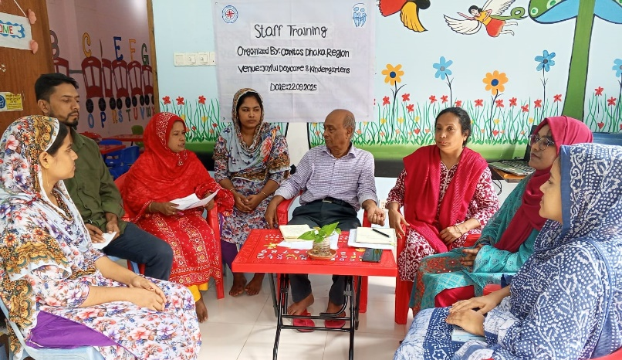
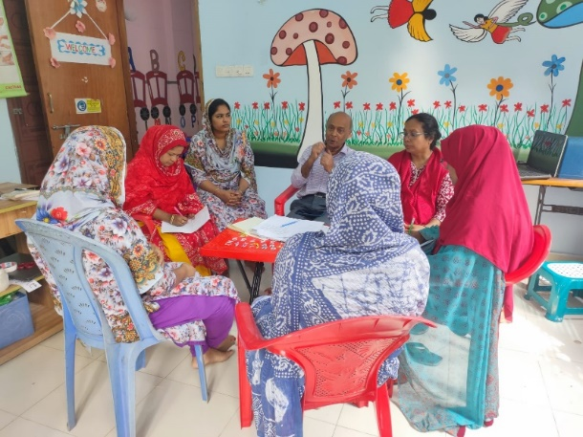
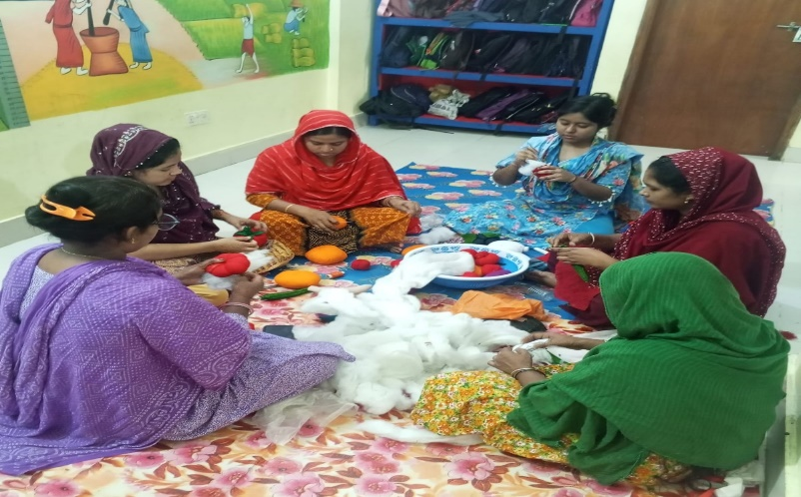
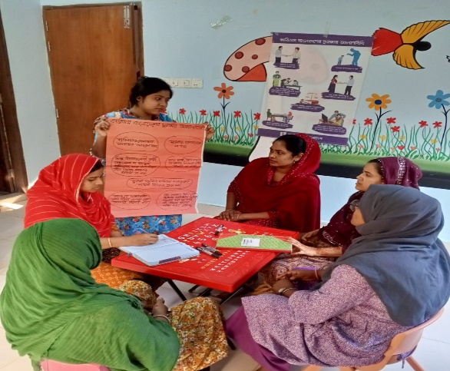

Story of Child:
Sl | Opinion from Child | Picture & VDO clip
1 | My name is Kaifa. I really enjoy staying here. I play, study, do morning circle, recite rhymes, and learn new things. I can talk with my friends and recite rhymes.  https://limewire.com/d/vBHyX#cEIsOZyj37 | 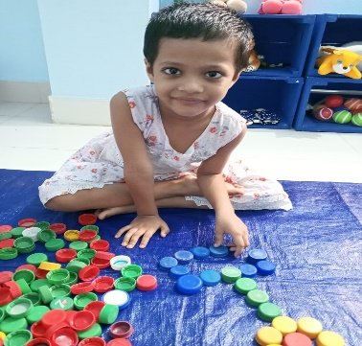
2 | My name is Arafat (6). My mother’s name is Rita, and my father’s name is Ilias. I can read and write ( Bengali alphabet) ka, kha, a, aa, and 1, 2.  https://limewire.com/d/sI6N5#fsgJ2YsWW0 | 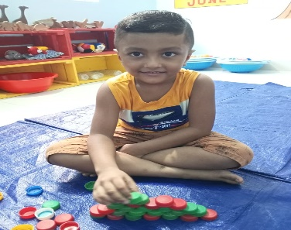
3 | Assalamu Alaikum( Greetings) ! My name is Adiba. I stay at the daycare center. I really like it here. I have many friends here. There are lots of toys. I play all day, eat, and sleep here.  https://limewire.com/d/jIjCB#x8HizQpJTz | 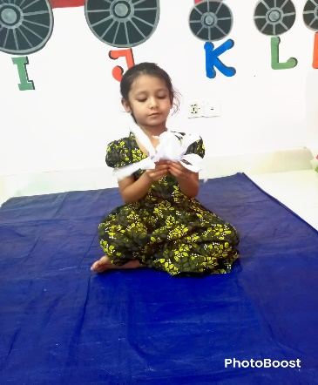
4 | My name is Ratna. I also stay at the daycare. I like being here very much. At daycare, I wash my hands with soap before eating. I wear sandals to go to the toilet. I enjoy being here a lot and play with my friends.  https://limewire.com/d/f4GJh#pOD0HPJQsN | 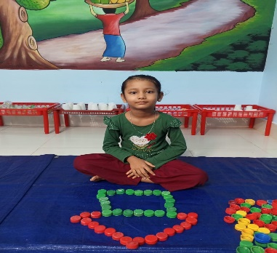
5 | My name is Cynthia. I have learned many things at the daycare center. I can read and write ka, kha, a, aa, and 1, 2.  For example:  অ – অজগরটি আসছে তেড়ে (A – The python is coming fiercely)  আ – আমটি আমি খাবো পেড়ে (Aa – I will eat the mango I pluck)  ই – ইলিশ ভাজা খেতে মজা (I – Fried hilsa fish tastes good)  https://limewire.com/d/oYP8H#Nuq4d22FLj | 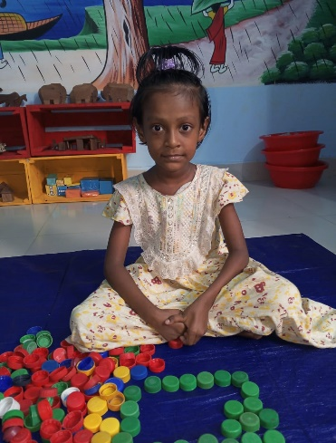

8: Overall Centre Performance, Observation & Recommendations:
At the kindergarten, each child stays engaged in various activities from morning to afternoon. Through the day-care program, children are kept safe and receive nutritious food. They also have the opportunity to study. Working mothers can now go to work without worry, leaving their children safely at the day-care center. The children play together, learn social interaction through group participation, and develop cooperation and mutual understanding. They play and study in groups, learning values through teamwork and helping each other. They are also learning to understand others’ feelings and to participate in all activities by following rules.
Children have learned practical skills such as hand washing and using the bathroom properly (wearing sandals, maintaining hygiene). They are also learning to identify colors, draw pictures, match objects, build with blocks, and use various educational materials.

In the community, social groups, adolescent groups, and children’s groups have been formed. Activities such as seminars on early childhood care and development, cooking demonstrations, day celebrations, children’s gatherings and food festivals, collection of recyclable materials, toy-making, meetings, and trainings have been organized. These initiatives have increased community awareness and participation. The community members are now actively supporting the implementation of day-care and kindergarten activities.
Recommendations:
- Increase the number of day-care and kindergarten centers and expands support in the community. This will allow low-income working parents to work without worry, knowing their children are safe.
- Ensure the availability of first aid facilities and employ a paramedic/nurse in the day-care centers
- Provide indoor and outdoor play materials for community children and organize cultural programs to help children develop their talents
- Arrange training sessions and exposure visits to enhance the skills and capacity of staff members.
Conclusion:
The “Joyful Day-Care and Kindergarten” project of Caritas Dhaka Region has made significant progress in supporting the safety, care, and holistic development of children from industrial areas of Ashulia. Despite challenges such as parental migration and job loss leading to some child dropouts, the initiative has successfully provided a secure, stimulating, and nurturing environment where children learn through play and develop socially, emotionally, physically, and intellectually. The engagement of parents through meetings, awareness seminars, and festivals has strengthened family relationships and increased their understanding of early childhood care and development. Community involvement has also been enhanced through group meetings, cooking demonstrations, and day observances, resulting in improved health, hygiene, and nutrition practices among families. Staff development efforts have built a competent and compassionate team dedicated to children’s well-being. Overall, the project has proven to be a valuable support system for working mothers and a beacon of hope for their children’s brighter future. To sustain and expand this positive impact, it is recommended to increase the number of centres, improve healthcare and play facilities, and continue capacity-building initiatives for both staff and parents.
Joyful DCC Activities Picture: https://limewire.com/d/3ySpy#GP0txb3BCV
Report Prepared by: Dhaka Project Team assisted by Subhash Saha
Date :29-10-2025

